Hawthorn Primary School

Curriculum 2023-2024
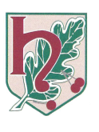

Inspire, Challenge, Achieve

Contents
Curriculum Area | Page Number
- Our Vision and Values | 3
- Our Curriculum Statement | 4-5
- Year group overviews | 6-13
- Planning | 14-15
- Assessment in all subjects | 16-20
- English | 21-27
- Maths | 28-30
- Science | 31-35
- Art and Design | 36-38
- Design and Technology | 39-41
- Geography | 42-44
- History | 45-47
- PSHE | 48
- Music | 49-54
- RE | 55-60
- Computing | 61-65
- BSL | 66

Vision and Values of Hawthorn Primary School
INSPIRE CHALLENGE ACHIEVE

Our aim is to embody our Vision Statement of INSPIRE, CHALLENGE, ACHIEVE through a
commitment to educate the whole child. Our Motto of ‘Individually We Matter – Together
We Shine’ c4aptures our belief in promoting respect for all, honouring the diversity of each Individual
and celebrating how living, working and learning together promotes a harmonious and strong community.
We commit to:
CHALLENGE by:
*promoting a Growth Mind-set in all children and adults within the
Hawthorn Community
*providing challenging learning opportunities that require deep-thinking and
application of skills
*creating an environment where aspiration is promoted and celebrated
*modelling a thirst for knowledge and respect for all

INSPIRE by:
*promoting a love of learning through a broad and balanced curriculum
*providing an engaging and vibrant curriculum that develops essential
skills for life and the future
* facilitating opportunities to be creative, to use ‘pupil voice’, to explore
and to apply English and Maths Skills in real life situations
*developing an understanding of learning as a life-long process, embracing
all opportunities given

ACHIEVE by:
*ensuring each child is provided with every opportunity to make progress
*promoting pride in success
*recognising ‘mistakes’ as a vital part of the learning process
*instilling a sense of pride in the process of learning and the
finished product

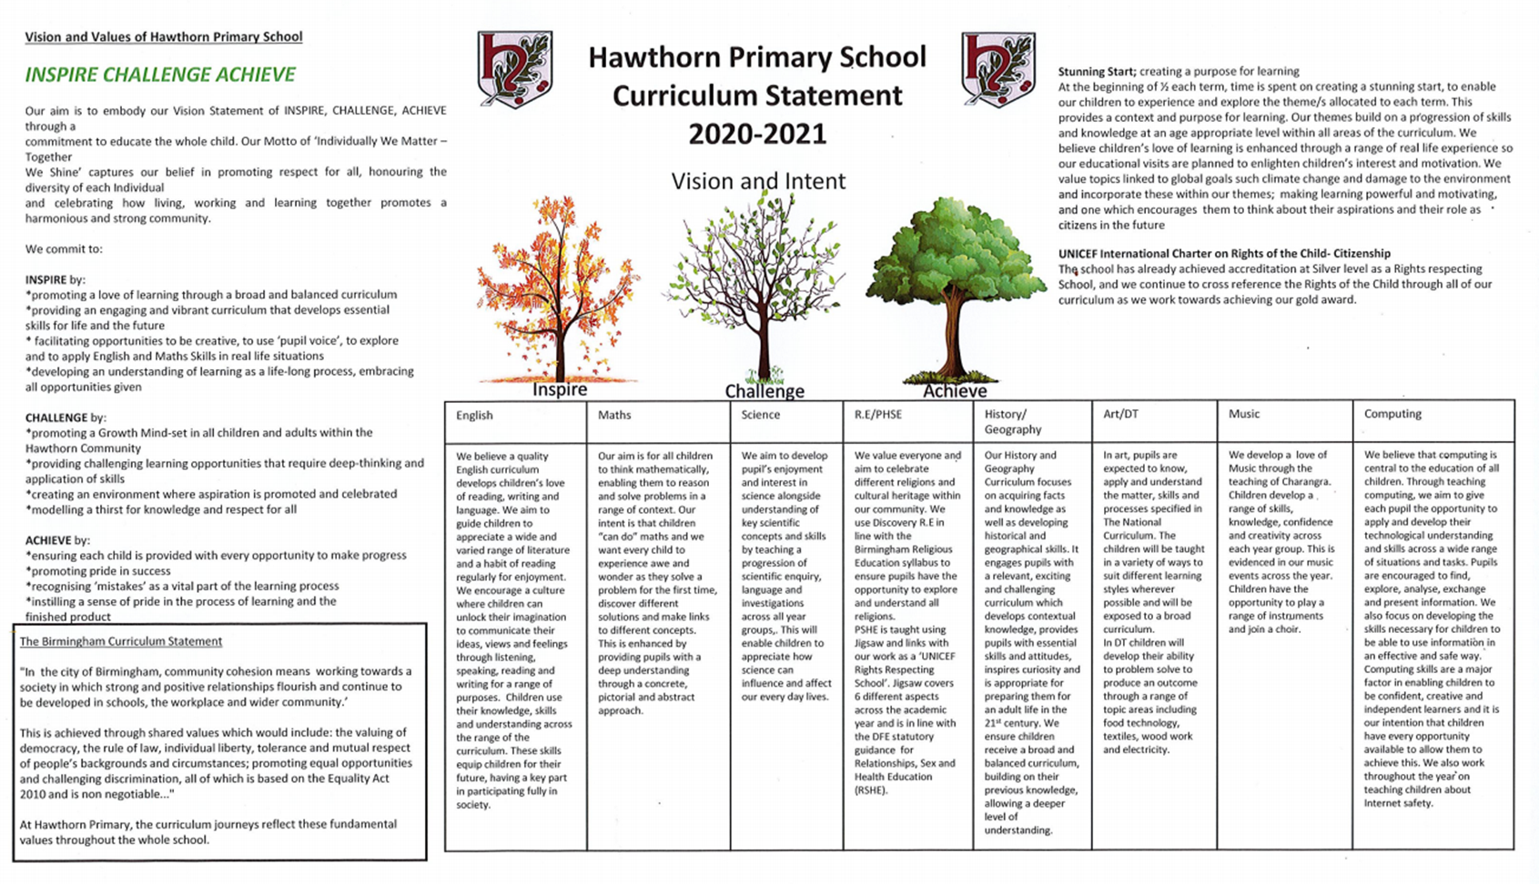

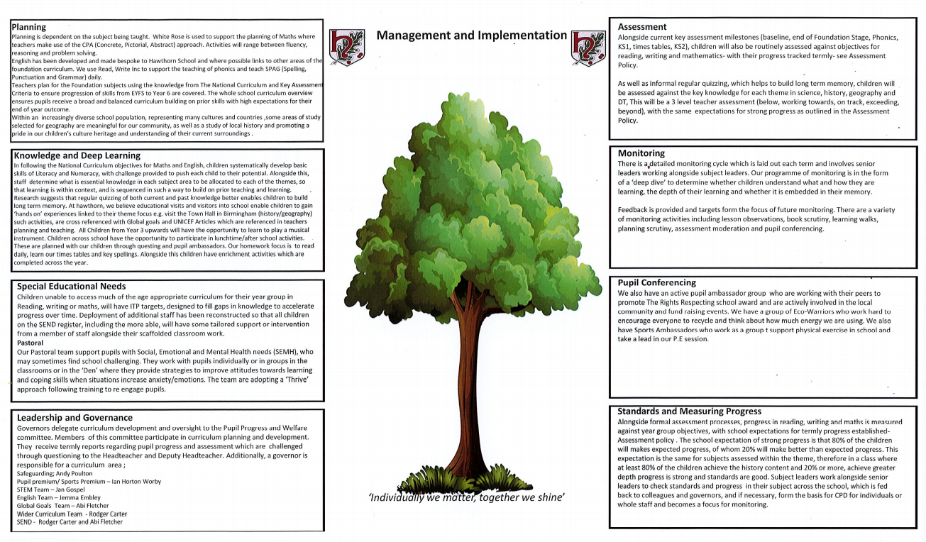

Nursery
Subject | Autumn 1 | Autumn 2 | Spring 1 | Spring 2 | Summer 1 | Summer 2
 | Ourselves and Our Families- Who am I? | The Natural World  Colour and Light | Our Wonderful World- Nothing Stays the Same. | Animals and transport  Would you like to go to the Zoo? | Minibeasts- Who lives at the bottom of my garden? | Celebrating Summer
English | See separate planning | See separate planning | See separate planning | See separate planning | See separate planning | See separate planning
Maths | See separate planning | See separate planning | See separate planning | See separate planning | See separate planning | See separate planning
UW | Ourselves and Our Families- Who am I?  (Family relationships and generations)  Technology all around (Computing/Technology) |  | People and places in my Community (Local area)  How do these work? (Computing/Technology)  Life Cycles |  | Places around the world  I can use apps! (Computing/Technology)
EAD | Painting self-portraits  Clay Diva Lamps (thumb)  Christmas Cards |  | Printing (Easter cards) |  | Drawing and Painting
Music | Rhymes and Routines |  | Exploring Voices making Sounds |  | Rhythm and Rhyme
PSHE | Circle Time | Circle Time | Circle Time | Circle Time | Circle Time | Circle Time
R.E | Special People | Christmas | Celebrations | Easter | Story Time | Special Places
P.E | Focus on  Extending Fundamental Movement Skills | Focus On Extending Fundamental Movement Skills | Throwing and Catching – Aiming Games | Bat/Ball Skills and Games | Athletics | Athletics

Reception
Subject | Autumn 1 | Autumn 2 | Spring 1 | Spring 2 | Summer 1 | Summer 2
Theme | Once Upon a Time… | Individually We Matter,  Together We Shine | Our Wonderful World and the wonderful words by  Julia Donaldson |  | Lovely Life Cycles | Oh, I do like to be beside the seaside…
English | See separate planning | See separate planning | See separate planning | See separate planning | See separate planning | See separate planning
Book/Author Focus | The Gingerbread Man  Traditional Tales | Jack and the Beanstalk  Traditional Tales | The Gruffalo  Julia Donaldson Books | Room on the Broom  Julia Donaldson Books | The Hungry Caterpillar  Eric Carle | Oliver Jefferson  Sue Hendra/Rachel Bright
Maths | WRM | WRM | WRM | WRM | WRM | WRM
UW  Science | How have I changed since I was a baby?  Learning about parts of the body (Gingerbread Man), food and growth, healthy habits. | Let’s get gardening!  (Jack and the Beanstalk)  Which Animals lay golden eggs? | A feast for the Gruffalo! Let's get cooking and discover where our food comes from.  Are all animals Nocturnal? | What do plants need to grow?  Growing our own fruit and vegetables  Exploring -  States of matter  Melting/Freezing/  Changes (bubbling potions) | Life Cycles – Observe the life cycle of a butterfly.  Is the life cycle of a butterfly the same as the life cycle of a hen? | Life under water – linked to Weston Super Mare educational visit
Seasons | Play, learn, and explore outside in all seasons and in different weather
UW  History  Geography | My Family Tree  My Journey to School  (look at and create their own simple maps) – Google Earth  Black History Month – Story ‘Look Up’ | The Gunpowder Plot ‘Guy Fawkes’  Remembrance Day  (London Landmarks/Queen Elizabeth)  Scotland – St Andrew’s Day | Our School and Our Local Community (Culture and Clothing)  (Including people who help us) | Nursery Rhymes  (Jack and Jill – Why did they have to go to a well to fetch a pail of water?)  (Polly Put The Kettle on – Why didn’t Polly plug the kettle in and turn it on?)  (How has life changed – e.g. electricity, running water).  Wales – St David’s Day  Ireland – St Patricks Day | Nursery Rhymes  (Wee Willie Winkie – Why did Willie Winkle carry a candle around town?)  England – St Georges Day |  | Visit to Weston Super Mare – Past and present holidays -  similarities  and differences  What can I do now? My Learning Journey through Reception
Our World | The children will be learning about natural and manmade ‘wonders’ from around the world.
EAD  Art  DT | Drawing and painting portraits (Artist Frida Kahlo)  Maths link - Kandinsky and Piet Mondrian  Let’s Get Baking! | Clay coil Diva Lamps (Artist Yayoi Kusama) Pumpkins available 31st October  My Christmas/Holiday card. | Collage – It’s a Gruffalo  String Printing  (Artist Peter Georgopoulos)  Preparing healthy drinks/snacks/meals | Observational drawing and painting – Mother’s Day blossom tree cards (Artist Van Gogh -Sunflowers)  Tile Printing (Easter Cards) (Artist Andy Warhol)  Animal Homes | Life cycle of butterfly – drawing and painting insects (Artists Matisse – The Snail ‘Painting with scissors’)  Animal Homes |  | Under water pictures, collage,  shading by adding  black or white.  (Artist Paul Klee – Goldfish)  Story Time – Class Assembly Props  How do things work? – Links to Computing
Music | Hey you/Rhythm in the way we walk |  | In the Groove/Round and Round |  | Your imagination/Reflect, rewind, replay
BSL | Alphabet/ Greetings/ Feelings & Emotions/ school/ communication and Christmas signs |  | Emotions & feelings/ Numbers/ Colours/ Days of the week |  | Birthdays/ Family Members/ Questions/Food & drink
PSHE | Being Me in My World | Celebrating Difference | Dreams and Goals | Healthy Me | Relationships | Changing Me
R.E | Special People | Christmas | Celebrations | Easter | Stories | Special Places
Computing | Technology All Around Us | Let’s Paint | Let’s Write | All About Instructions | Programming with Bee Bots | Digital Literacy/Project Evolve
P.E | Fundamental Movement Skills  Locomotion /Dance | Fundamental Movement Skills  Object Control Skills | Fundamental Movement Skills  Locomotion /Dance | Fundamental Movement Skills  Object Control Skills | Athletics and Multi Skills/Dance | Athletics and Multi-skills
Year 1 Overview
Subject | Autumn 1 | Autumn 2 |  | Spring 1 | Spring 2 |  | Summer 1 | Summer 2
English | See separate planning | See separate planning |  | See separate planning | See separate planning |  | See separate planning | See separate planning
Maths | WRM | WRM |  | WRM | WRM |  | WRM | WRM
Science | Seasonal Change | Human Body | Materials | Animals | Caring for the planet | Planting | Plants | Growing and Cooking
History | Great Fire of London |  |  | Changes in Living Memory: Toys |  |  | Significant Individual: Florence Nightingale & Mary Seacole
Geography | Fieldwork Unit: Our School |  |  | UK |  | Hot and Cold
Art | Painting: John Griffer |  |  | Collage: Pete Blake Toys |  |  | Drawing: Julian Opie
DT | Mechanisms: Moving Storybooks |  |  | Textiles: Puppets |  |  | Preparing Fruit and Vegetable
Music | Hey you/Rhythm in the way we walk |  |  | In the Groove/Round and Round |  |  | Your imagination/Reflect, rewind, replay
PSHE | Being Me in My World | Celebrating Difference |  | Dreams and Goals | Healthy Me |  | Relationships | Changing Me
R.E | Creation Story | Christmas |  | Jesus as a friend | Easter – Palm Sunday |  | Shabbat | Rosh Hashanah and Yom Kippur
Computing | Just Paint and write-All About Me-Part 1 | Collect Photographs and Paint Pictures Part 2 |  | Gathering Data and Creating Charts | Simple Algorithms and Programs Part 1 |  | Create Simple Programs Part 1 | Digital Literacy
BSL | Alphabet/ Greetings/ Feelings & Emotions/ school/ communication and Christmas signs |  |  | Emotions & feelings/ Numbers/ Colours/ Days of the week |  |  | Birthdays/ Family Members/ Questions/Food & drink
P.E  INDOOR | Gymnastics | Dance  Animals |  | Gymnastics | Gymnastics |  | Dance  Weather | Gymnastics
P.E  OUTDOOR | Focus on  Extending Fundamental Movement Skills | Focus On Extending Fundamental Movement Skills |  | Throwing and Catching – Aiming Games | Bat/Ball Skills and Games |  | Athletics | Athletics
Year 2 Overview

Subject | Autumn 1 | Autumn 2 |  | Spring 1 | Spring 2 |  | Summer 1 | Summer 2
English | See separate planning | See separate planning |  | See separate planning | See separate planning |  | See separate planning | See separate planning
Maths | WRM | WRM |  | WRM | WRM |  | WRM | WRM
Science | Uses of everyday materials | Animals need for survival | Humans/plastic | Plants (light and dark) | Living things and their habitats |  | Plants (bulbs and seeds) | Growing up
History | Explorers |  |  | History in their own locality – Aston Hall |  |  | Events beyond living memory: first aeroplane flight
Geography | Similarities and differences between 2 cities, Birmingham and Calcutta |  |  | Fieldwork unit: Surrounding school (further afield) |  | The world around us
Art | Painting: William Tuner |  |  | Sculptures: Clarice Cliff |  |  | Drawing: aeroplanes
DT | Wheels and Axles: designing a vehicle |  |  | Balanced diet: Making a wrap |  |  | Structures: Chair for Baby Bear
Music | Hands, feet, heart/Ho Ho Ho |  |  | I wanna play in a band/Zootime |  |  | Friendship song/Reflect, rewind, replay
PSHE | Being Me in My World | Celebrating Difference |  | Dreams and Goals | Healthy Me |  | Relationships | Changing Me
R.E | What did Jesus teach? | Christmas – Jesus as a gift from God |  | Passover  Prayer at home | Easter – Resurrection |  | The Covenant  Community and Belonging | Rites of Passage and good works  Hajj
Computing | Ways to present information | Art of animation |  | Collect photographs and paint pictures (Y1 objectives) | Collecting, organising and presenting data |  | Create simple programs (Y1 objectives) | Digital Literacy
BSL | Alphabet/ Greetings/ Feelings & Emotions/ school/ communication and Christmas signs |  |  | Emotions & feelings/ Numbers/ Colours/ Days of the week |  |  | Birthdays/ Family Members/ Questions/Food & drink
P.E  INDOOR | Gymnastics | Multi-skills  Locomotion Skills / Physical Literacy |  | Dance  Life Cycles | Gymnastics |  | Dance  Habitats | Multi-skills  Object Control Skills / Physical Literacy
PE  OUTDOOR | Using Fundamental Movement Skills in small games | Using Fundamental Movement Skills in |  | Making Up Games with a Partner | Small-Sided Group Games |  | Athletics | Athletics

Year 3 Overview
Subject | Autumn 1 | Autumn 2 |  | Spring 1 | Spring 2 |  | Summer 1 | Summer 2
English | See separate planning | See separate planning |  | See separate planning | See separate planning |  | See separate planning | See separate planning
Maths | WRM | WRM |  | WRM | WRM |  | WRM | WRM
Science | Skeleton | Nutrition and diet | Rocks | Fossils | Soils | Light | Plants | Forces | Magnets
History | Changes in Britain: Stone Age to Iron Age |  |  | Romans in Britain |  |  | Ancient Egypt
Geography | Fieldwork Unit: Sutton and Sutton park |  |  | Volcanoes and earthquakes |  | The UK
Art | Monoprinting: Stone Age Cave Painting |  |  | Collage: Gaudi (Roman Mosaics) |  |  | Drawing/Painting Egyptian Art
DT | Electrical Circuits: Torches |  |  | Eating Seasonally |  |  | Structures: Castles/3D
Music | Let Your Spirit Fly/Glockenspiel Stage 1 |  |  | Three Little Birds/The Dragon Song |  |  | Bringing us Together/Reflect, rewind, replay
PSHE | Being Me in My World | Celebrating Difference |  | Dreams and Goals | Healthy Me |  | Relationships | Changing Me
R.E | Diwali  The Amrit Ceremony and the Khalsa | Christmas |  | Jesus’ Miracles | Easter – Forgiveness |  | Hindu Beliefs  Sharing and Community | Pilgrimage to the River Ganges  Prayer and Worship
Computing | Ways to present (Y2 objective) | Art of Animation (Y2 objective) |  | Create a Topic Based ebook (Y2 objective) | Creating a Branching Database and Interrogating Databases |  | Write a Program-Block Based Sequences-Part 1 | Digital Literacy
BSL | Alphabet, Greetings and numbers 0-20 |  |  | Emotions/feelings and Family |  |  | Days of the week/Months of the year and weather/seasons and colours
P.E  INDOOR | Gymnastics | Dance |  | Gymnastics | Gymnastics |  | Net, Court and Wall Games | Outdoor and Adventurous Activities
P.E  OUTDOOR | Invasion Games | Create Ball Games |  | Net, Court and Wall Games | Striking and Fielding Games |  | Outdoor and Adventurous Activities | Athletics

Year 4 Overview
Subject | Autumn 1 | Autumn 2 | Spring 1 | Spring 2 |  | Summer 1 | Summer 2
English | See separate planning | See separate planning | See separate planning | See separate planning |  | See separate planning | See separate planning
Maths | WRM | WRM | WRM | WRM |  | WRM | WRM
Science | States of Matter | Group abd classify living things | Sound | Electricity |  | Habitat | The digestive system
History | Anglo Saxons |  | Vikings |  |  | Ancient Greeks
Geography | Sustainability and energy |  | Fieldwork Unit: Walmley Village |  | Greece VS UK
Art | Drawing: Anglo Saxons |  | Viking Shield and Symbols |  |  | Sculptures:Ancient Greeks/Clay Pots
DT | Textiles: Fastening |  | Pneumatics: Monster Box |  |  | Food: Adapting a Recipe
Music | Whole Class Instrumental Lessons |  | Whole Class Instrumental Lessons |  |  | Whole Class Instrumental Lessons
PSHE | Being Me in My World | Celebrating Difference | Dreams and Goals | Healthy Me |  | Relationships | Changing Me
R.E | Beliefs and Practices  Buddha’s Teachings |  | Passover  The 8-fold path | Easter |  | Rites of Passage and good works  The 8-fold path | Prayer and Worship
Computing | Storytelling and Presenting Information (Y3 objective) | QR Codes (Y3 objective) | Creating an Interrogating Simple Databases | Write a Program Part 1 Block Based Sequences |  | Write a Program Part 2 Drawing Shapes | Digital Literacy
BSL | Alphabet, Greetings and numbers 0-20 |  | Emotions/feelings and Family |  |  | Days of the week/Months of the year and weather/seasons and colours
P.E (Indoor) | Gymnastics | Dance-Anglo Saxons | Gymnastics | Dance-Electricity |  | Gymnastics | Team Building Activities
P.E (outdoor) | Net, Court and Wall Games | Problem solving and inventing games (Invasion) | Invasion Games | Striking and Fielding Games |  | Orienteering / Map Reading | Athletics

Year 5 Overview
Subject | Autumn 1 | Autumn 2 |  | Spring 1 |  | Spring 2 | Summer 1 |  | Summer 2
English | See separate planning | See separate planning |  | See separate planning |  | See separate planning | See separate planning |  | See separate planning
Maths | WRM | WRM |  | WRM |  | WRM | WRM |  | WRM
Science | Properties and changes of materials | Forces | Space | Space |  | Animals including Humans | Reproduction | Reversible an Irreversible changes | Reproduction
History |  |  |  |  | Crime and punishment
Geography |  |  |  |  | Our World
Art
DT | Structures: Playground |  |  | Food: Healthy Eating
Music
PSHE | Being Me in My World | Celebrating Difference |  | Dreams and Goals |  | Healthy Me | Relationships |  | Changing Me
R.E | Belief into action  Prayer and Worship | Christmas |  | Beliefs and moral values |  | Easter | Prayer and Worship  Beliefs and moral values |  | Beliefs and Practices
Computing | Multi-Media Fact File (Y4 objective) | Creating and Using Spreadhseets to solve problems |  | What is Computer Technology? (Y4 objective) |  | Scratch (Y4 objective) | Scratch (Y4 objective) |  | Digital Literacy
BSL | Alphabet, Greetings and numbers 0-20 |  |  | Emotions/feelings and Family
P.E  INDOOR | Team Building Activities | Team Building Activities |  | Leadership Training |  | Gymnastics | Net, Court and Wall Games |  | Striking and Fielding Games
P.E  OUTDOOR | Outdoor Adventurous Activity  Small Groups Orienteering | Invasion and Target |  | Invasion Games |  | Striking and Fielding Games | Net, Court and Wall Games |  | Athletics

Year 6 Overview
Subject | Autumn 1 | Autumn 2 |  | Spring 1 | Spring 2 |  | Summer 1 |  | Summer 2
English | See separate planning | See separate planning |  | See separate planning | See separate planning |  | See separate planning |  | See separate planning
Maths | Place Value  Addition, subtraction, multiplication and division. | Fractions  Converting Units |  | Ratio  Algebra  Decimals | FDP  Area & Perimeter  Statistics |  | Shape  Position and Direction |  | Consolidation, themed projects and problem solving.
Science | Living Things i their Habitats | Electricity  (Unit on renewable energy) |  | Light  (Unit on light pollution) | The Circulatory System | Diet, drugs and lifestyle | Variation | Adaptations | Fossils
History | WWII |  | Monarchy
Geography | North America |  |  | Fieldwork : HS2 line
Art | Drawing and Painting: Henry Moore
DT | Structures: Bridges |  |  | Electrical Systems: Steady Hand Game
Music | Happy/Classroom Jazz 2/A New Year Carol
PSHE | Being Me in My World | Celebrating Difference |  | Dreams and Goals | Healthy Me |  | Relationships |  | Changing Me
R.E | What is the best way for Muslims to show commitment to God? | Do Christmas celebrations help Christian’s to understand Jesus? |  | Is anything ever eternal? | Is Christianity still a strong religion 2000y after Jesus’ was on Earth? |  | Does belief in Akhira help Muslims lead good lives? |  | How did Jesus create a ‘new covenant’ and what does that mean today?
Computing | Understanding Big Data | Artificial Intelligence and  Machine Learning |  | Analyse and Interpret Data using Spreadsheets | E-Safety |  | The Internet and World Web |  | Game Design
BSL
P.E  INDOOR | Team Building Activities | Team Building Activities |  | Leadership Training | Outdoor and Adventurous Activity |  | Net, court and wall games  Tennis |  | Net, court and wall games  Tennis
P.E  OUTDOOR | Net, court and wall games | Invasion Games |  | Invasion Games | Striking and Fielding Games |  | Athletics |  | Athletics

Planning

Planning for English.
In English we have created our own bespoke curriculum, making links between spelling, reading and writing as well as identifying areas within the wider curriculum where we can make cross curricular links.
Planning for Maths
At Hawthorn Primary we use White Rose Maths to support the teaching of The National Curriculum. For some children who work with the Resource Base or have an identified special educational need, we use a range of suitable materials to plan an individual curriculum whilst maintaining coverage across all areas of Maths.

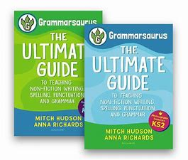
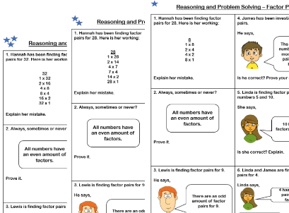
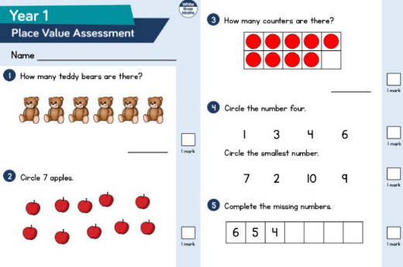
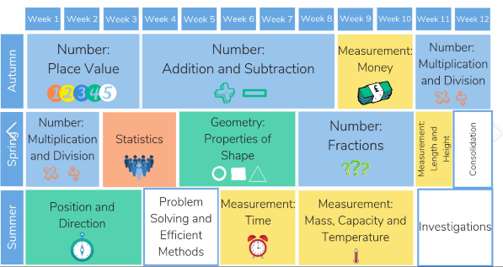

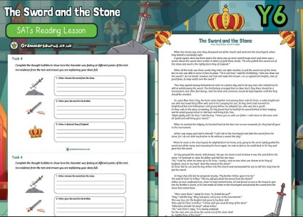
Planning for Foundation Subjects.
Planning for the Foundation subjects incorporates The National Curriculum statements and ensures the all skills outlined in the assessment criteria are taught. The skills are built on through our curriculum and we have ensured that we have a well-planned whole school curriculum where pupils are given the opportunity to make links and develop knowledge.

Skills.
The skills in our planning are taken from a progression document where the Key Assessment Criteria is recorded and ensures progression between year groups. We have planned our curriculum to ensure all skills are covered at least once in each year group.
Knowledge
This is taken from The National Curriculum and our whole school curriculum ensures that all areas within each subject that are statutory are taught across the Key Stage.
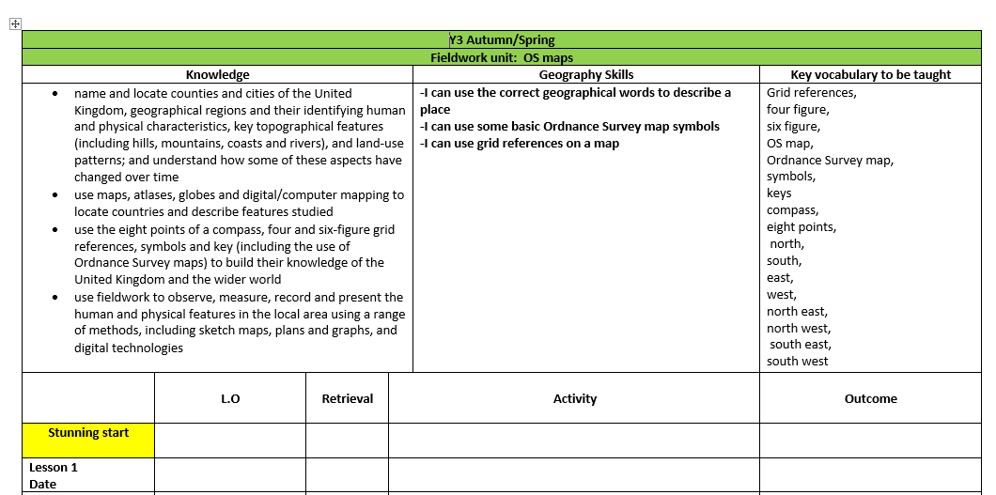

Key Vocabulary.
This enables us to pre teach the vocabulary, especially so to our SEND pupils. We will plan the use of this vocabulary in other subject areas and ensure we have displayed this on our working walls.
Stunning Start
We will begin each new unit of work with an excitement, hands on learning opportunity to support pupils learning and engagement.
Retrieval
We will ensure that children have opportunity to build on the previous learning and understand the importance of retrieval to ensure the children can recall previous learning in order to build on it.

Assessment
See separate assessment policy for more information about assessment systems in school.
Assessment in English and Maths
Teachers use the school’s electronic tracking system Educater to record their teacher assessment judgements for reading, writing and maths at the end of each term. EYFS use Tiny Tracker to assess children across the areas of the EYFS curriculum.
To aid these judgements, at the end of each term children in Years 1 - 6 take the National Test Style (NTS) assessments in Reading and Maths as well as the GaPS grammar test. These tests are used to inform teacher assessment as well as identify gaps in learning for both individuals and the whole class. Intervention and adapted planning is then used as a tool to support pupil's progress.

Assessment in the Foundation Subjects and Science.
As part of assessment and the process of identifying areas for further development, we assess pupils in science, history, geography, computing, art, design and technology, music, PSHE, R.E and P.E using the skills identified in the planning overview.
Teachers assess using a range of methods. All the assessment through a range of different models ensures the curriculum is tailored to meet the needs of pupils, adapted where needed, and that pupils are supported in the next steps of their learning.
Teachers will use the subject assessment to identify those skills that need further teaching, pupils who may be finding a particular subject difficult, as well as identifying areas for development within the curriculum.

Assessment in Writing
What: Diagnostic analysis of writing
Who: Adults/teacher
When: After each initial write to see what needs to be taught next.

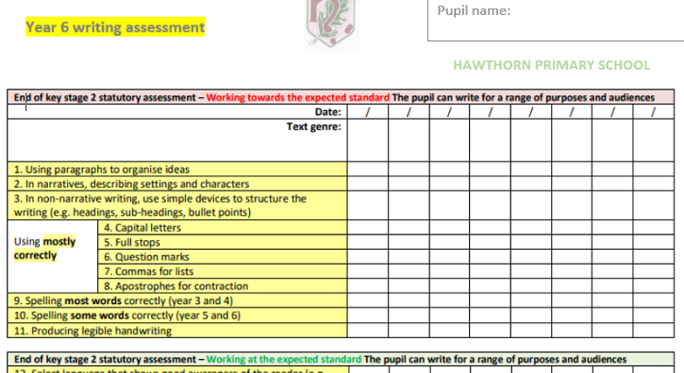

What: Assessment checklist
Who: adults/teacher
When: After each independent write.

What: SPaG testing
Who: children
When: End of each term
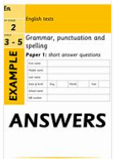

Assessment in Reading
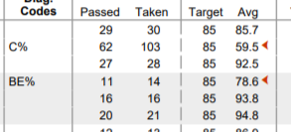
What: Accelerated Reader
Who: All children to complete weekly quizzes on appropriately ranged books. Teachers to monitor this.
When: weekly

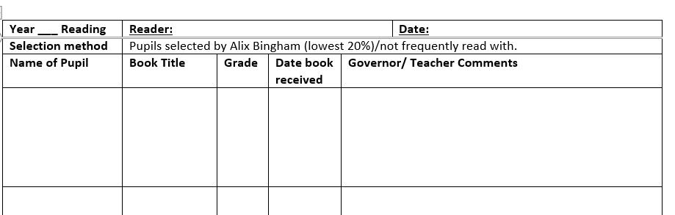
What: Class reader
Who: volunteer reader to fill in form.
When: According to reading timetable.
How well has the child read? Did they FIH or FT the words? Did they stumble on any words?

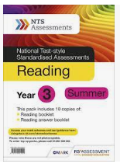
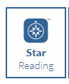
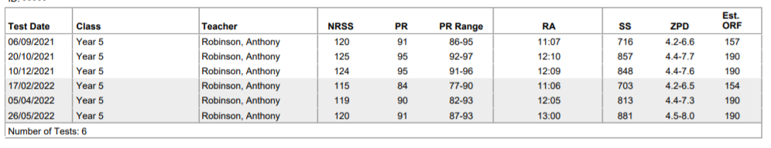
What: STAR reader
Who: Children
When: End of each half term to get new reading range.
What: NTS tests
Who: Children
When: End of each term.

Assessment in Maths
What: Assessment in maths
Who: Adults/teacher
When: Throughout each lesson teachers and support staff use AFL to assess pupils, adapt the planning and support children who need it through Keep up interventions.

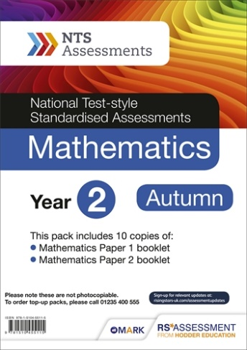
What: NTS tests
Who: Children
When: End of each term.

What: TT Rockstars-Children complete the multiplication work online.
Who: Adults monitor the progress through the dashboard
When: weekly

Assessment in History
History Assessment at Hawthorn Primary School.
What: Learning objectives.
Who: Class teacher or teacher who has taken the lesson.
When: End of each lesson.
WTS, MA and A will be used to highlight how successfully children have met the skills from the lesson and provide guidance on who needs extra support for the next lesson. This should inform planning for the following week.

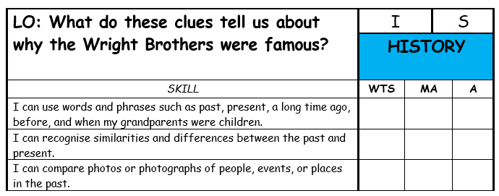

What: Two page spread
Who: Children to complete and teachers to mark.
When: End of each unit of work.
This is to be knowledge based. Children to produce a two-page spread with everything they can remember from that unit of work. Can be presented in anyway.

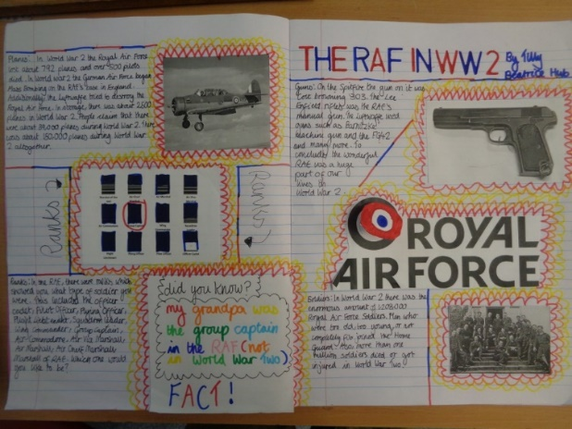

What: Evaluation of unit of work.
Who: Class teacher.
When: End of each unit of work.
To highlight what has worked well and to find the children that found anything tricky. This can then be used in the next unit to identify target children.

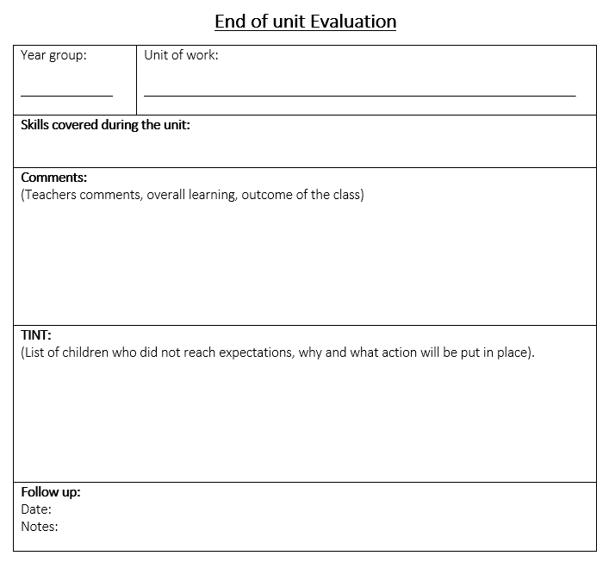

Assessment in Geography
Geography Assessment at Hawthorn Primary School.
What: Learning objectives.
Who: Class teacher or teacher who has taken the lesson.
When: End of each lesson.
WTS, MA and A will be used to highlight how successfully children have met the skills from the lesson and provide guidance on who needs extra support for the next lesson. This should inform planning for the following week.

s

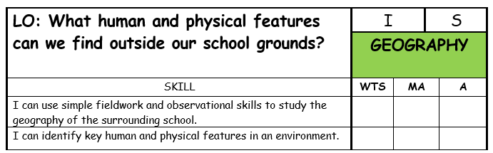

What: Two page spread
Who: Children to complete and teachers to mark.
When: End of each unit of work.
This is to be knowledge based. Children to produce a two-page spread with everything they can remember from that unit of work. Can be presented in anyway.

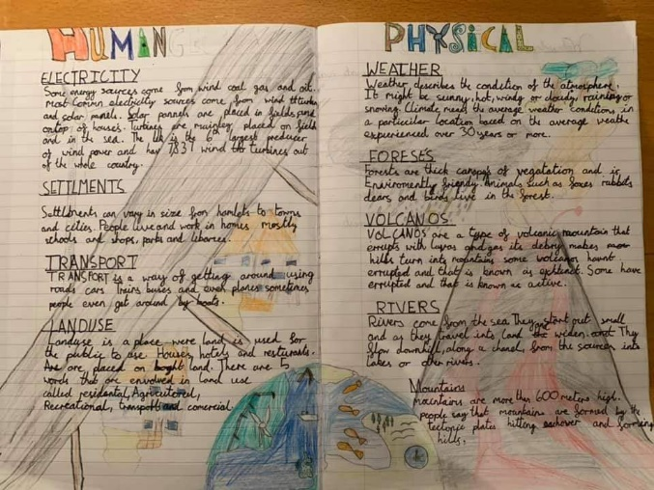

What: Evaluation of unit of work.
Who: Class teacher.
When: End of each unit of work.
To highlight what has worked well and to find the children that found anything tricky. This can then be used in the next unit to identify target children.

Assessment in Science
Intent & Implementation: What to do first.
Pre assessment at the beginning of the area of study
At the beginning of each unit, the children should engage in a pre-assessment activity to ascertain what they already know. This can be a retrieval style task that looks back at prior learning that the children should have already accessed. This will provide an opportunity to see what the children already know and any gaps that may be there with knowledge (helps to support future planning).
Impact:
Assessing children’s prior knowledge allows us to focus and adapt our teaching plans. For our children, it helps them to construct connections between previous knowledge and new knowledge. It identifies gaps and dispels misconceptions which may be significant, or we might need to address.
Intent & Implementation: What the children do next.
Retrieval tasks
At the beginning of each weekly lesson, the children could be given a question (or questions) from STEM Science assessments and/or Test Base questions. In addition to this, you could either design your own or use any other suitable publication that meets the science objective you have covered and are assessing. N.B., it is likely you might need to generate more than one question to meet the breadth and depth of the science objective as written in the National Curriculum.
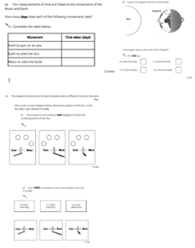

Impact
Retrieval practice, used as a strategy at the beginning of each lesson, will bring embedded information to mind which enhances and boosts learning. Recalling information, as a tool for learning, gives our children an opportunity to recall, consolidate knowledge and examine what they have learned thus, ready for the next step on their learning journey.

Intent & Implementation: On-going Assessment – Teacher
Science spreadsheet
This is best updated as soon as you have completed each science objective and/or a Working Scientifically objective as written in the National Curriculum. To judge that a child has met the standard for primary science, teachers need to have evidence that demonstrates consistent attainment of all the statements within the standard; both for ‘working scientifically’ and for ‘science content’. Therefore, as mentioned before in the ‘Retrieval tasks’, it is likely you might need to generate more than one question to meet the breadth and depth for each science objective as written in the National Curriculum.
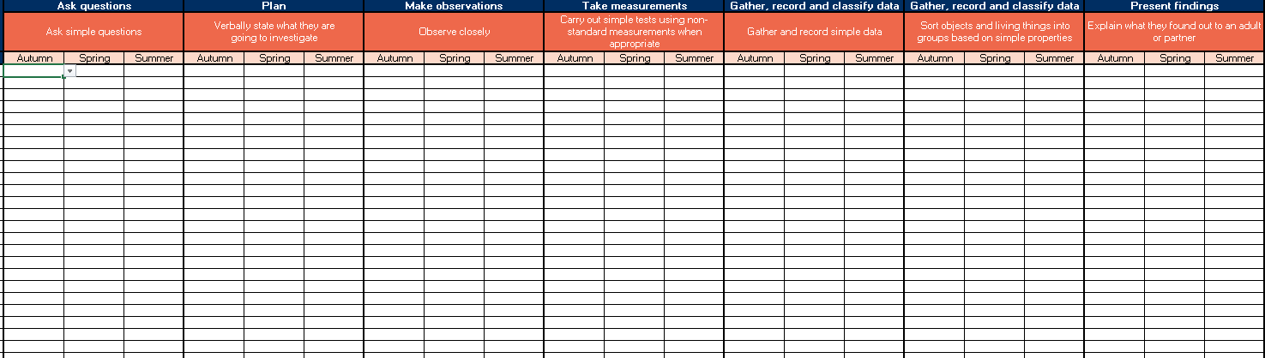
Impact
We will have a quick overview of the standards in science throughout the school. This information will support any curriculum changes to raise standards in science and overall school improvement. The science lead and all stakeholders, immediately, will know how well the class and/or any individual is performing and highlight any revisiting, intervention and/or pre-teaching. It will give an idea of which areas of science the children know well, which areas have been a challenge and it informs the science lead, current teacher and the next teacher of their focus. It will also give rise to any necessary adaptations needed in planning and resources requirements for better practice.

Assessment in Computing
All assessment documents, for KS1 and KS2, are presented as ‘knowledge organisers’ and can be found on the Entrust website: https://sites.google.com/gedu.demo.link2ict.org/computing-scheme-of-work/home.
These run along-side all the planning units for each year group.
What: KS1 and KS2 formative teacher
assessment.

Who: every child: demarcate SEN (with a
green spot), and PP (red spot) as
appropriate.

When: at the end of each lesson / end of
unit (teacher discretion)
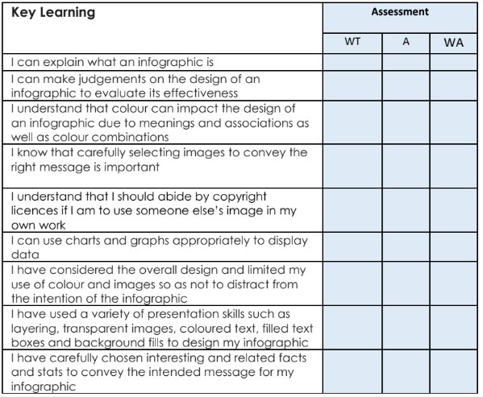
*units can be completed in any order.

Assessment documents, for EYFS and Nursery, can be found on staff shared: Curriculum 2022 – Computing assessment – EYFS and Nursery ( These are also presented as ‘knowledge organisers’)
What: EYFS/ Nursery teacher assessment.

Who: one complete for the whole class.

When: at the end of each taught unit.

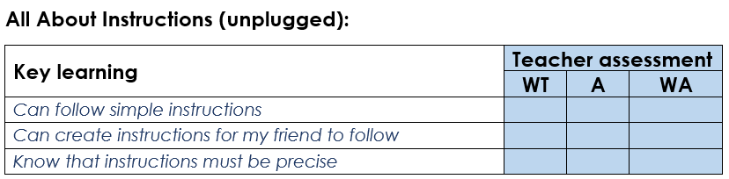

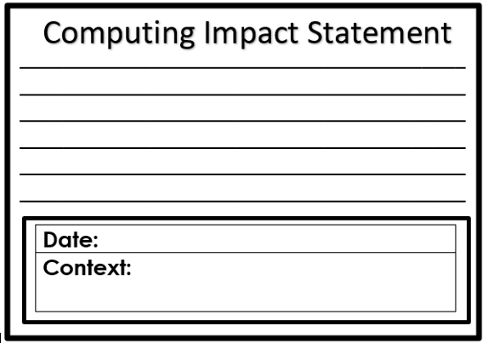
What: Impact statement (EYFS and Nursey)
Who: class teacher: one completed for the
whole class
When: at the end of each taught lesson.
How has the session impacted on learners?
What has been the result of the lesson?

Pupil self assessment can be located within shared files on each individual child’s J2Launch page (https://www.j2e.com ). For KS2, Nursery, EYFS, these can be opened in J2e5 and for KS1, these can be opened in JiT5.
What: KS2 pupil self-assessment (in J2e5)

Who: each child to complete.

When: at the end of each taught unit

How: children to drag the ticks to the
correct columns. Children to then
record an oral account of what they
have learnt/enjoyed.

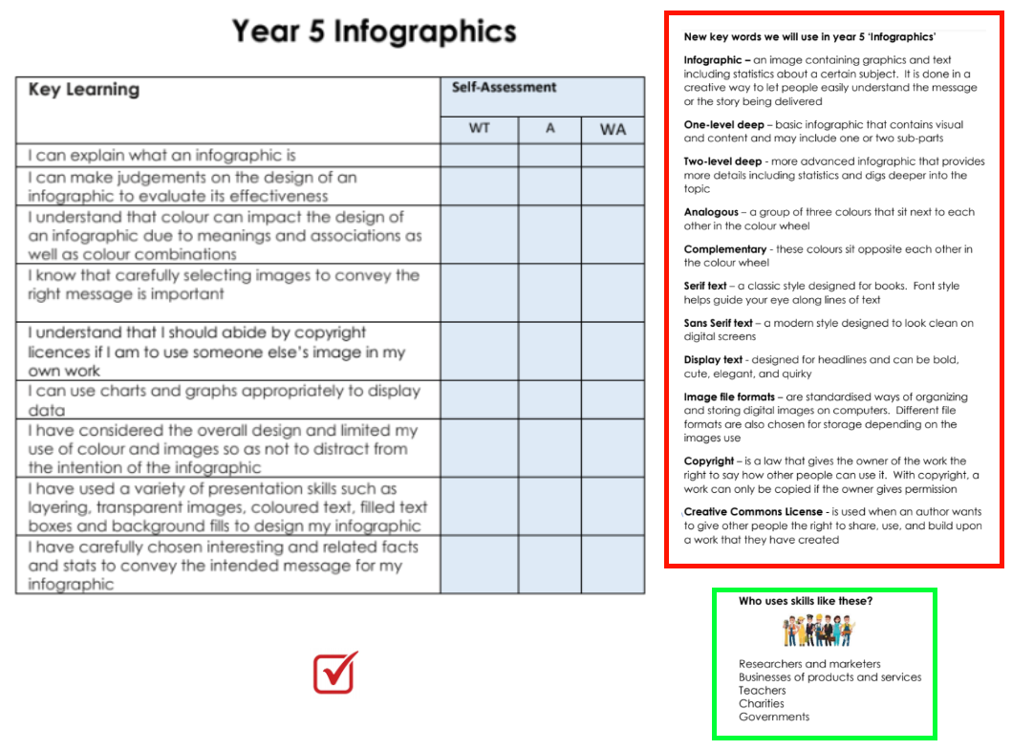
What: KS1 pupil self-assessment (in JiT5)

Who: each child to complete.

When: at the end of each taught unit

How: children to add tick to the
correct columns. Children to then
record an oral account of what they
have learnt/enjoyed.
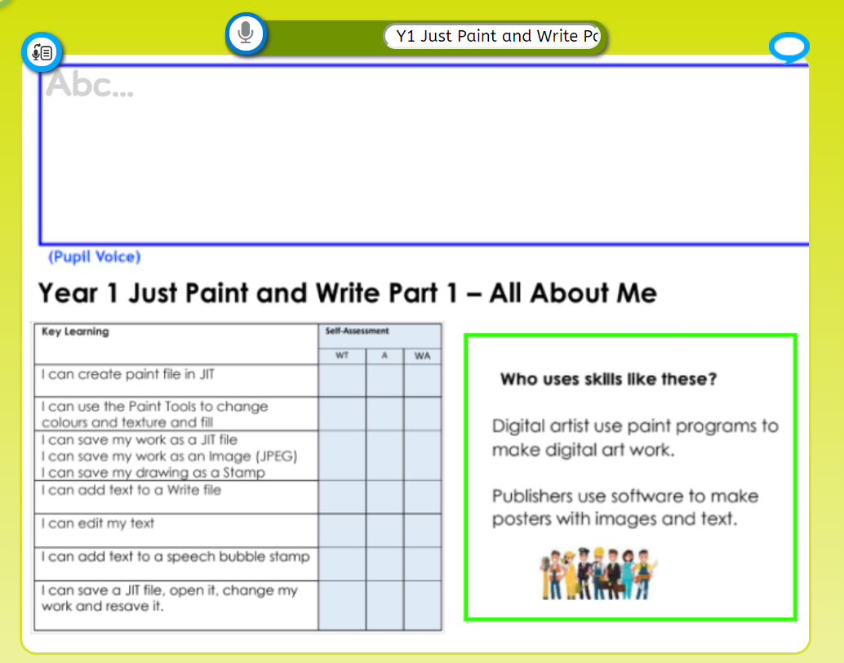
What: Nursery / EYFS teacher assessment
(in jJ2e5)

Who: Class teacher to complete for whole
class.

When: at the end of each taught unit

How: Drag the ticks to the correct columns.
Teacher to select 3 children to show
the array of abilities/understanding
and add a recording an oral account of
what they
have learnt/enjoyed.

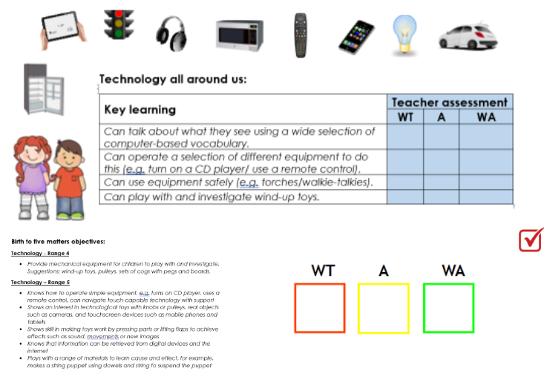

Hawthorn Primary – Online/ e-Safety Assessment

Every year group (except for Nursery) will have a ‘Digital Literacy’ Unit as part of their scheduled Computing Curriculum. This covered Online Safety / e-Safety. This can be accessed through Project Evolve (https://projectevolve.co.uk/toolkit/) which covers all the objectives from the government document ‘Education for a connected world’ (https://www.gov.uk/government/publications/education-for-a-connected-world )
In addition to this, every year group (except Nursery) should ensure online safety, from these objuestives, is taught at least once every half term.

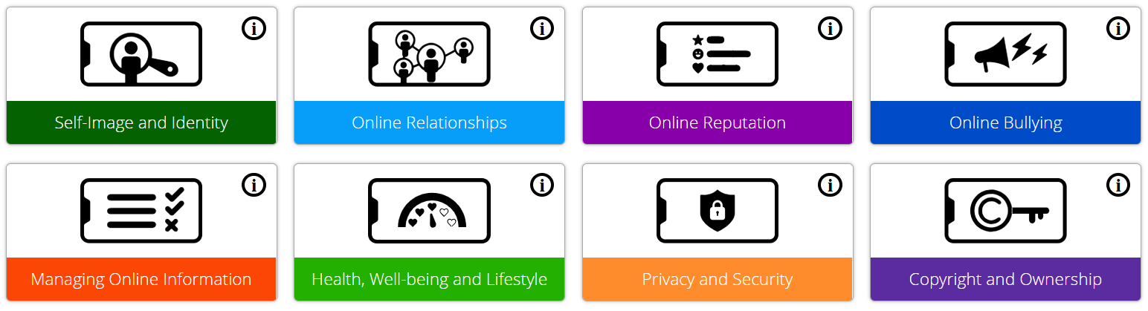
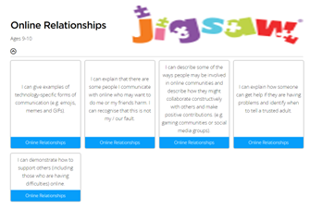
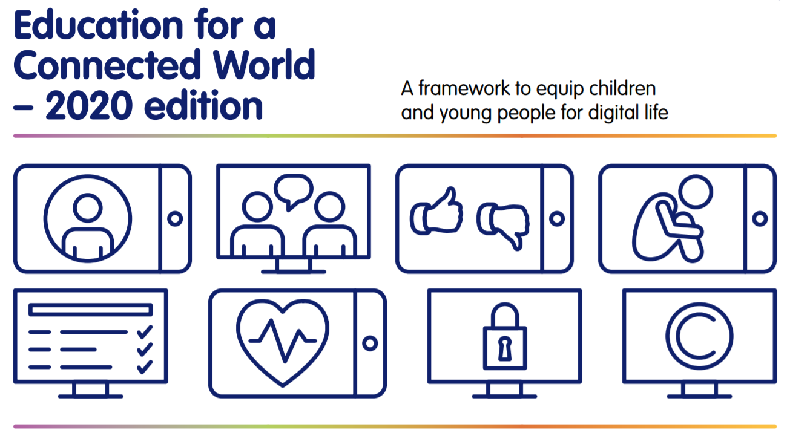
What: Impact statement

Who: class teacher: one completed for the
whole class

When: at the end of each taught lesson.
How has the session impacted on
learners?
What has been the result of the
lesson?

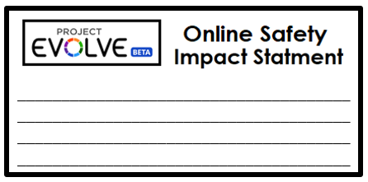

Assessment in Art

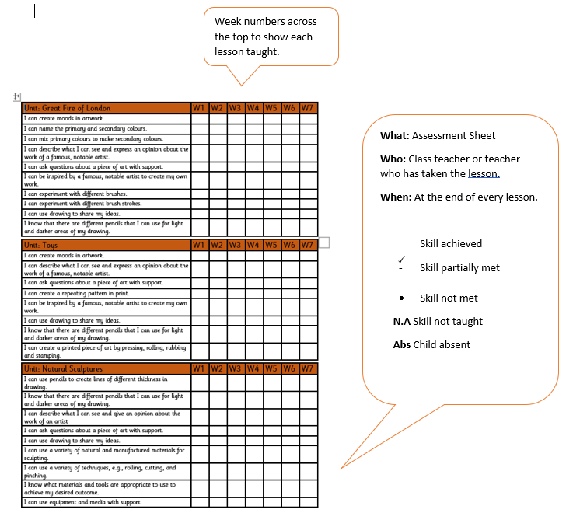

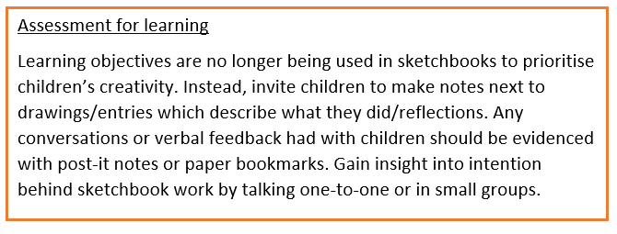

Assessment in Design and Technology

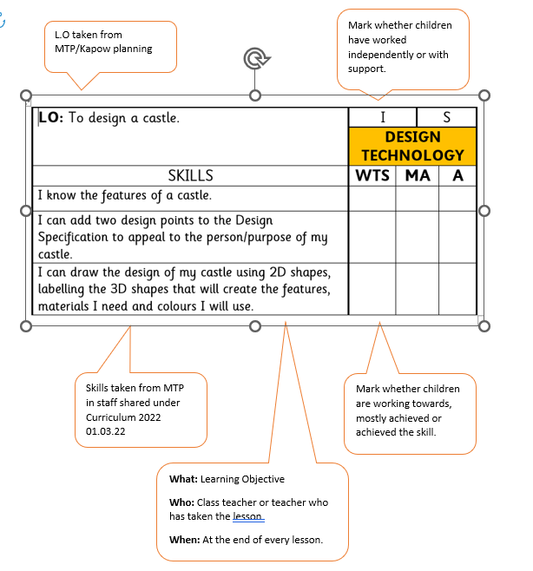

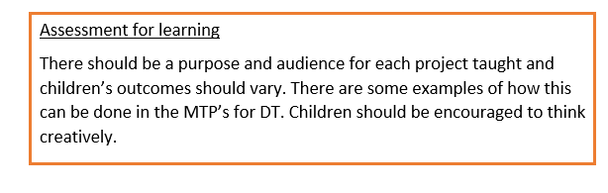

Assessment in Music
Music is to be assessed on a half termly basis using the Teacher Assessment documents from Charanga and the school assessment sheets for Music. Assessment will be used to inform planning so that children are all able to access the curriculum and be successful. The school assessment sheets will show what teachers are putting into place for individual children, who are finding it difficult to access certain parts of the curriculum, in the ‘Comments’ column. All of the documents are on Staff Shared, Curriculum 2022 01.03.22, Music.
Teacher Assessment document from Charanga.
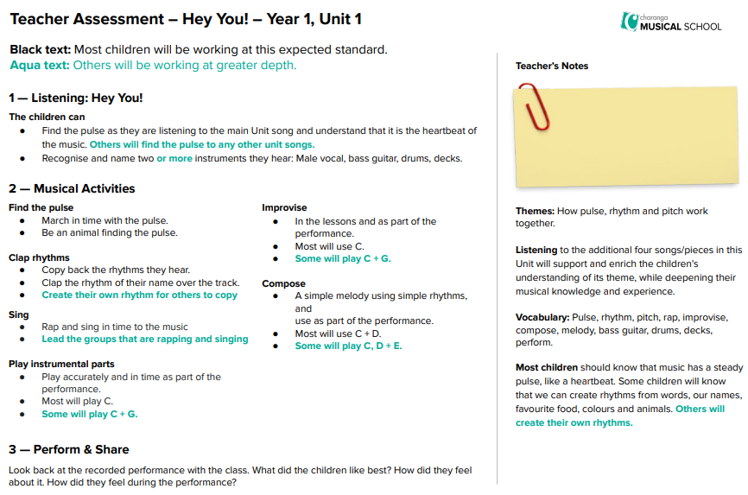
School Assessment Sheet.
Year …... Term 1……………………………………. Key: . working towards working at + working above
Name | Listen and appraise | Games | Singing | Playing Instruments | Comments (What does the assessment tell you? What actions will you make for next term? Who needs support? Who is greater depth?)

There are 7 areas of Music to be assessed.
In the first half term the areas to assess are: Listen and Appraise, Games, Singing and Playing Instruments.
In the second half term the areas to assess are: Improvisation, Composition and Perform and share.
On the school assessment sheets the children will be given : . for working towards, a tick for working at and + for working above.

Assessment in Physical Education
P.E Assessment Guidance.
To access the PE Assessment Excel sheet, click on:
R Drive,
Curriculum 2022 01.03.22,
P.E 2022,
Year 4 PE Assessment.

- On the Excel document you will see your class list to the left and the areas of P.E across the top.
- You will RAG rate and assess the children using the following colours. Green = achieved,Orange = partially achieved and Red = not achieved.
- The ‘I can’ statements link to the numbers across the top for the different aspects of P.E. (Please see the images below which are highlighted with a red circle.)
- Over time, you should be able to see your Excel document start to collate quickly.
- At the bottom of the Excel document, I have included a box for any Gifted and Talented children that may excel during P.E lessons.

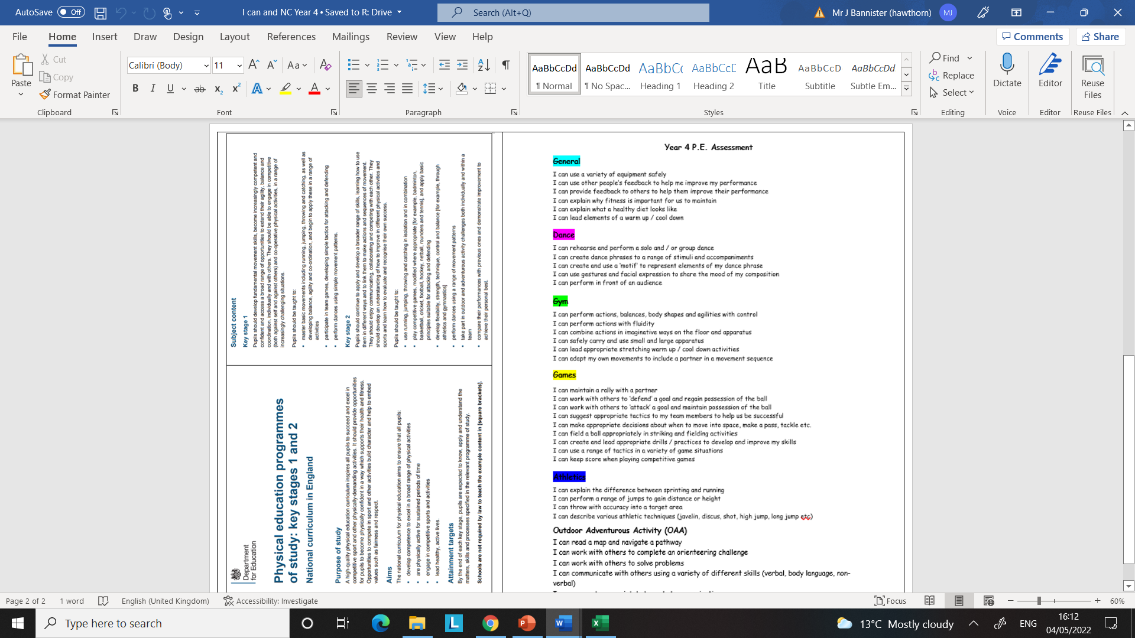

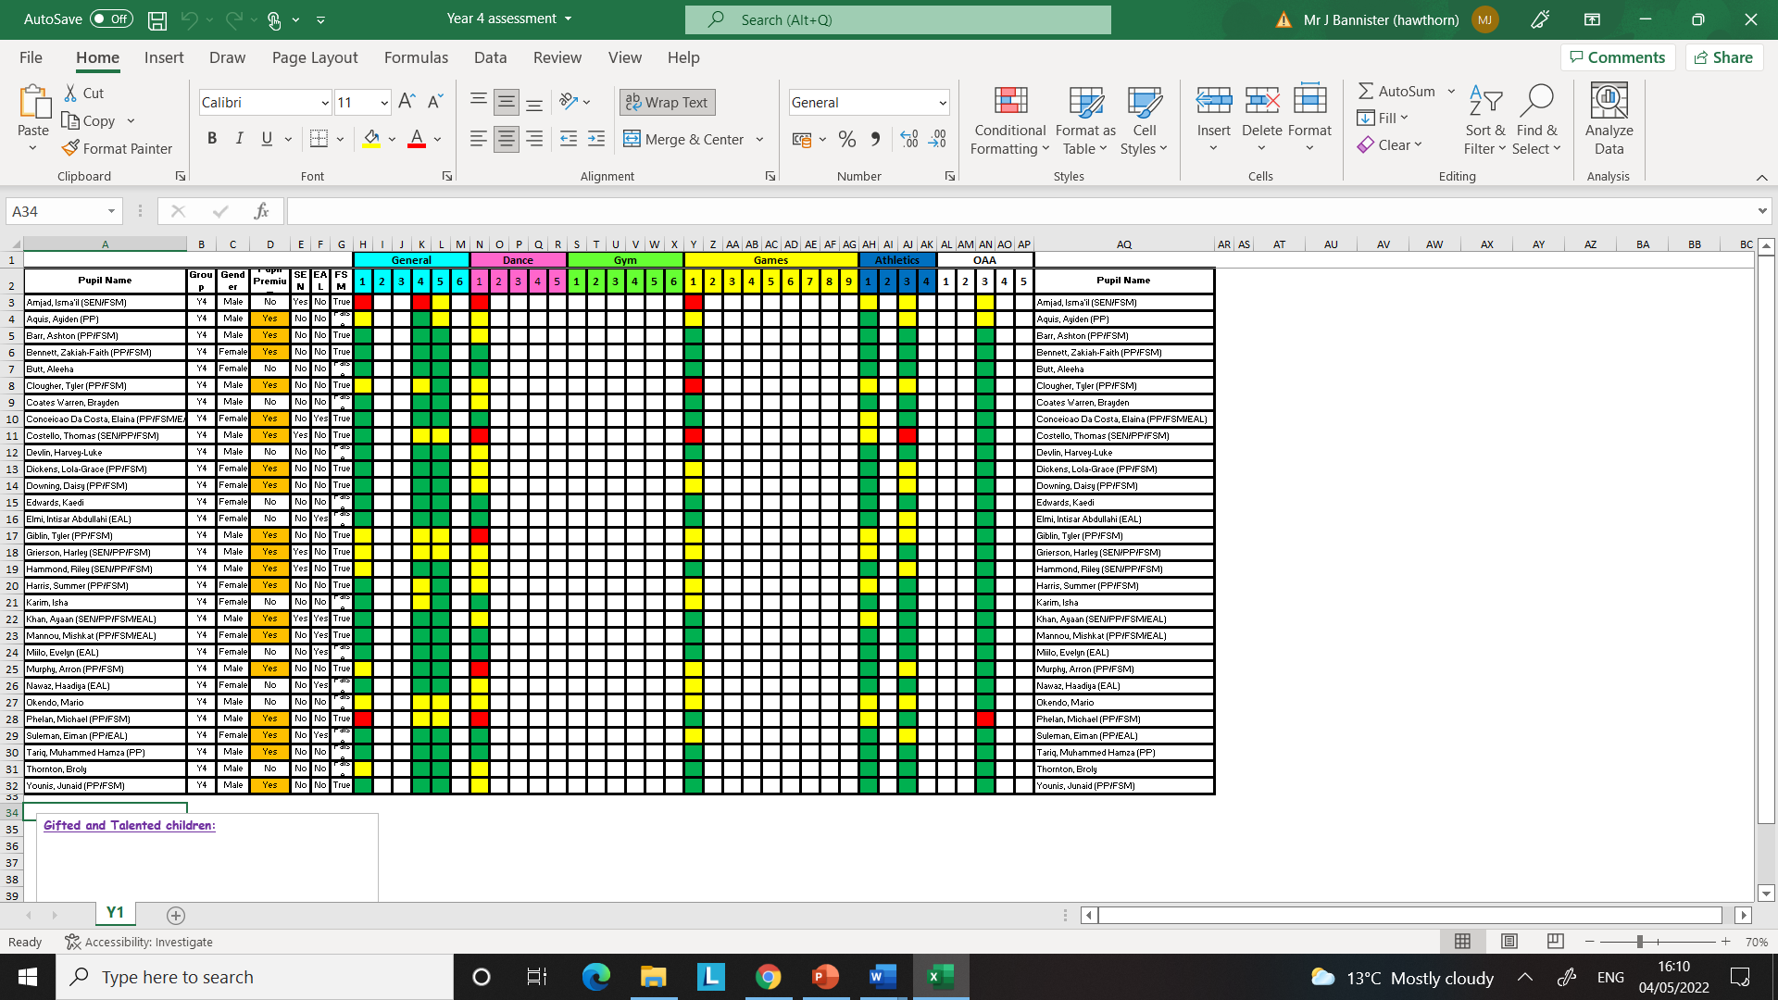

Assessment in Religious Education
What: Impact sheet
Who: Class teacher or teacher who has taken the lesson
When: End of the lesson
How has this session contributed to the ongoing enquiry? What has been the result of the lesson?

What: Pupil self-assessment
Who: Can be completed as a group (tables)
Individual or as a class
When: At the end of a lesson
What concepts did they struggle with? What skills will help in the next lesson?

What: Assessment of outcomes
Who: Class Teacher or teacher who has taught unit
When: Complete at the end a term e.g. Summer 1

Assessment in PSHE
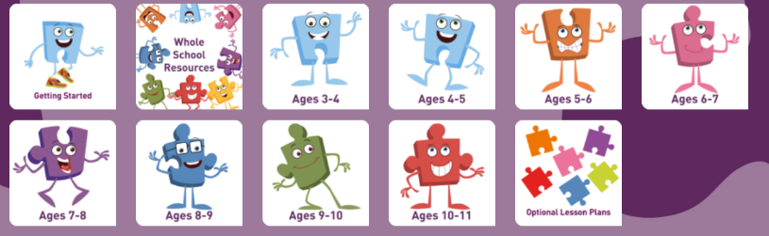
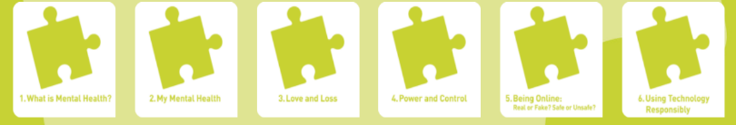
What: Pupil self assessment per lesson
Who: 3 x examples kept per lesson inc SEN (green spot), PP (red spot) and one more child of choice.

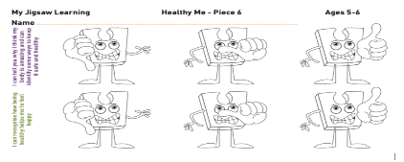
KS1 (in slides) KS2 (in slides)
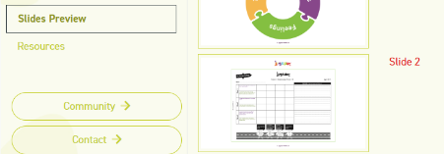
What: Impact sheet
Who: Class teacher or member of staff taking the lesson.
When: End of lesson.
How has the session impacted on learners? What has been the result of the lesson?
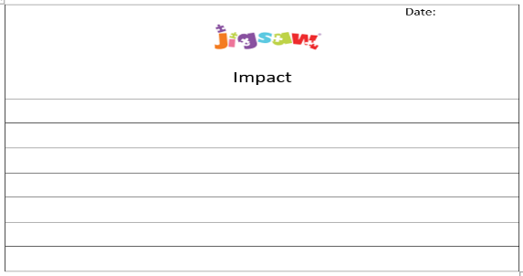

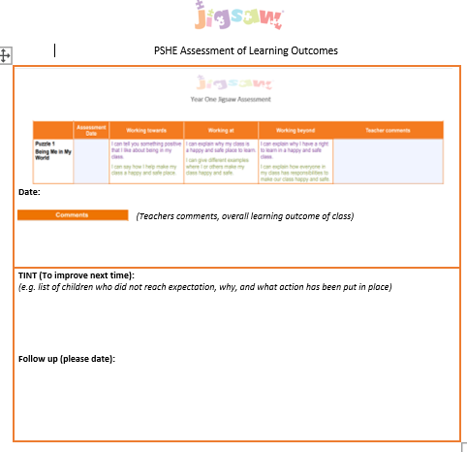
What: Assessment of outcomes
Who: Class teacher or member of staff taking lesson.
When: End of each puzzle/half termly eg end of Summer 1/Relationships.

Assessment in BSL
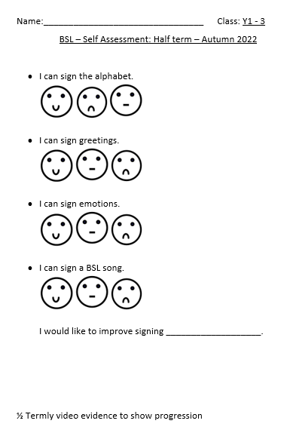
What: Self assessment

Who: Pupils

When: at the end of each half term children self-assess against the objectives outlined in the planning.

What: Assessment

Who: Teachers/Support staff/Subject leaders

When: at the end of each half term children are recorded using the focus signs taught. These are kept as evidence to show progress.

English Yearly Overview
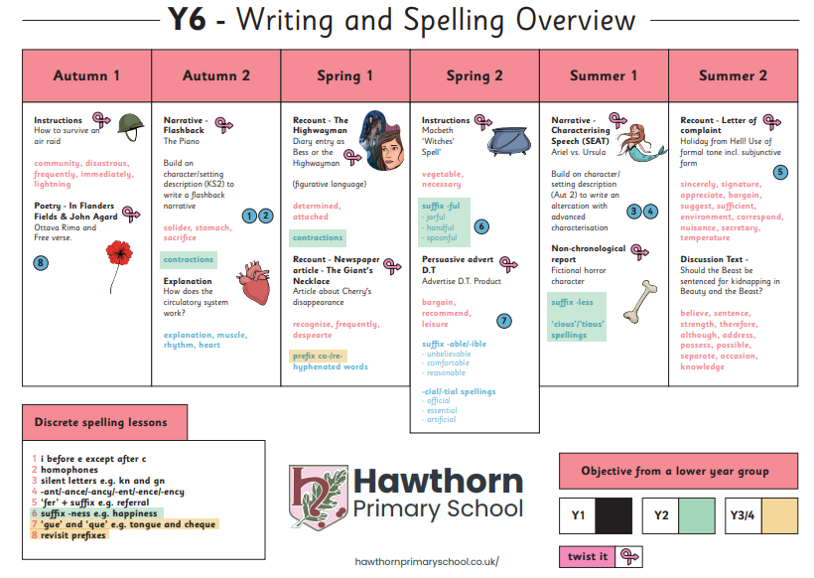
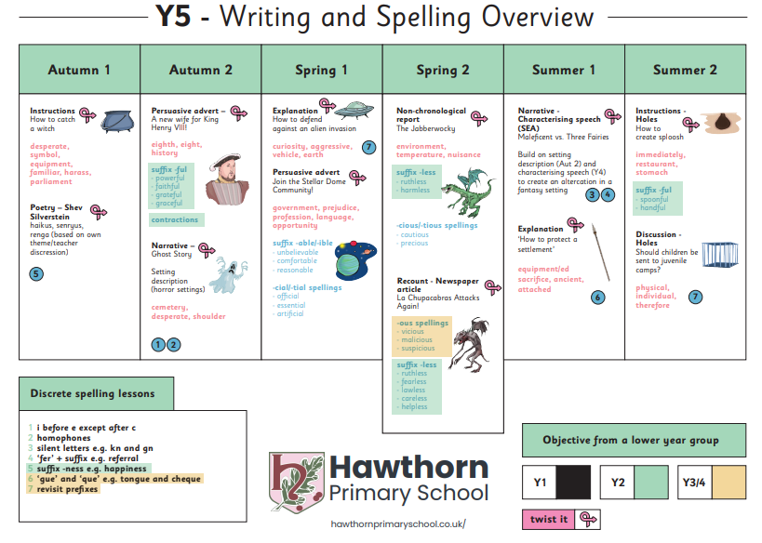
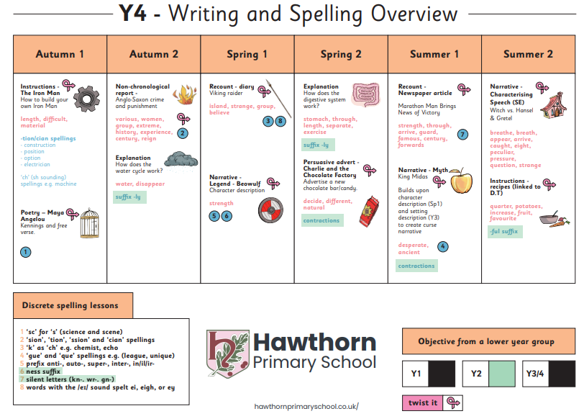
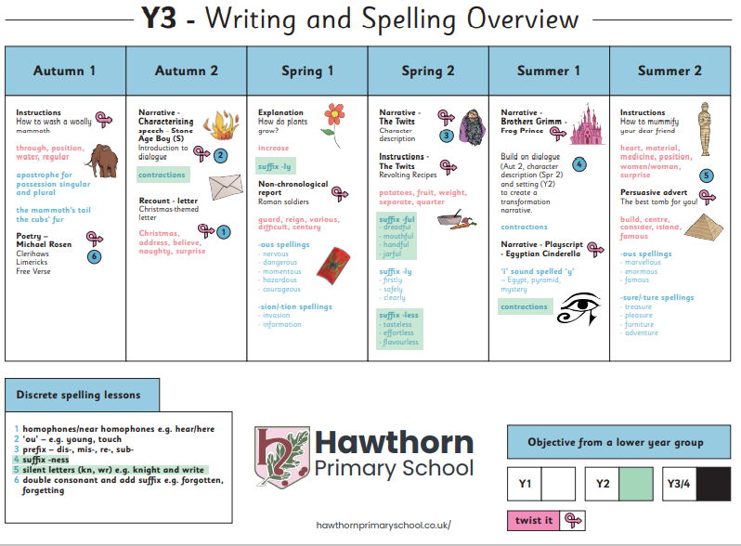
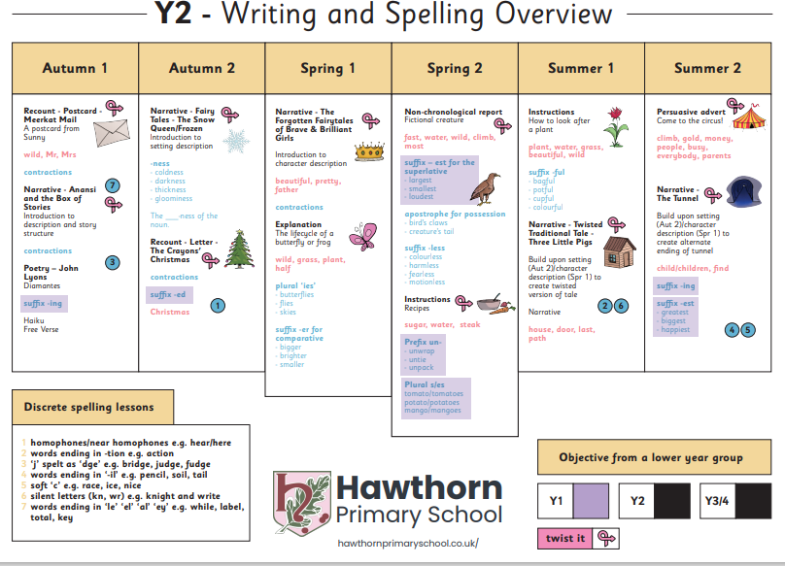
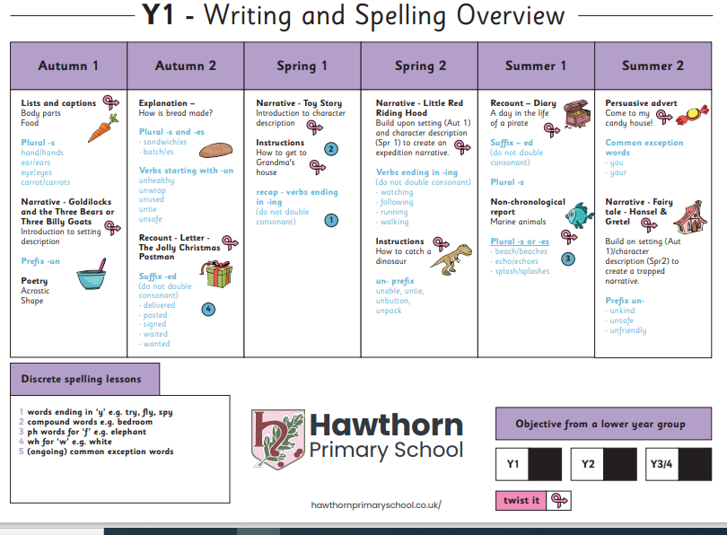
Maths Yearly Overview
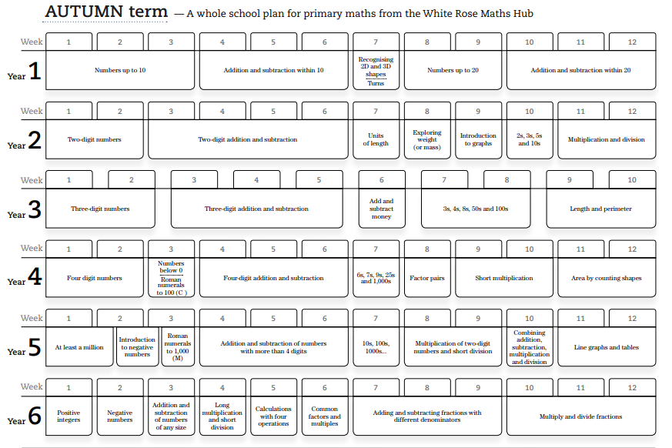
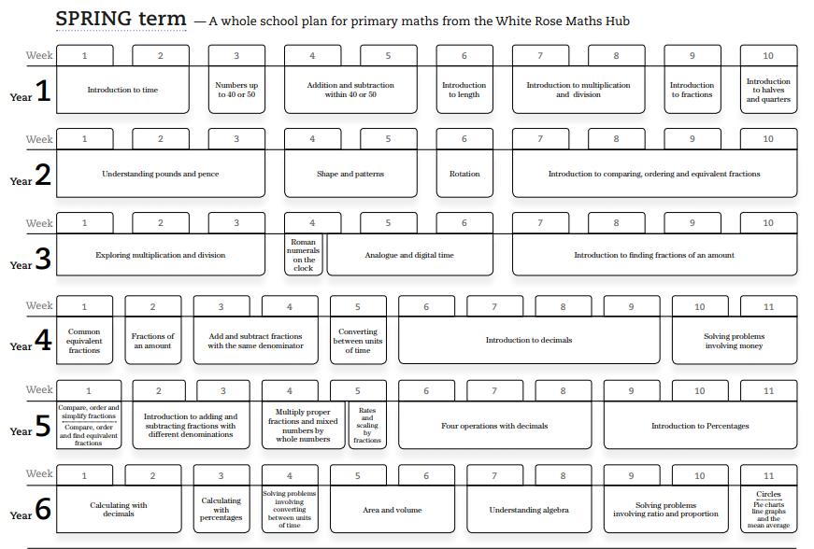
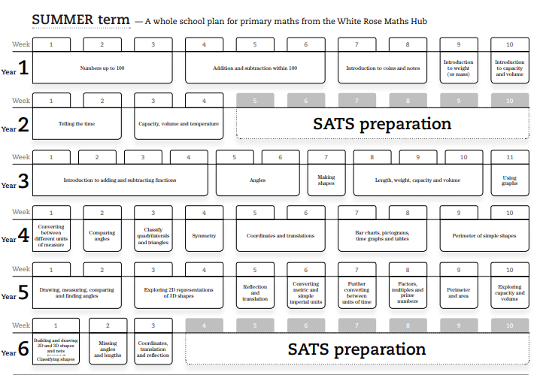
Science Whole School Overview
 | Autumn 1 | Autumn 2 | Spring 1 | Spring 2 | Summer 1 | Summer 2
Nursery | The World (Natural) |  | Life Cycles |  | Minibeasts
Reception | How have I changed?  Which animals lay golden eggs? |  | Let’s get cooking!  Planting fruits and vegetables. Where does our food come from? What do plants need to grow?  Are all animals nocturnal? |  | Are all life cycles the same?  Life Under Water. Plastic in the Ocean!
Year 1 | The Human Body  Seasonal Changes  Materials |  | Planting  Animals  Caring for the Planet  Seasonal Changes |  | Plants  Planting  Growing and cooking  Seasonal Changes
Year 2 | Animals needs for survival  Humans  Materials  plastic |  | Plants  Living things and their habitat  Light and dark |  | Plants – bulbs and seeds  Wildlife  Growing up
Year 3 | Skeletons  Movement  Diet and nutrition  Food waste  rocks |  | Fossils  Soil  Light |  | Plants  Forces  Magnets  Biodiversity
Year 4 | Group and classify living things  States of matter |  | Sound  Electricity  Energy |  | Habitats  Deforestation  The digestive system  Food chains
Year 5 | Forces  Space  Global warming |  | Properties of materials  Animals including humans  Life cycles |  | Reproduction  Reversible and irreversible changes  Plastic pollution
Year 6 | Living Things and Their Habitats  Electricity  Renewable energy |  | Light  Light pollution  The circulatory system  Diet, drugs, and lifestyle |  | Variation  Adaptations  Fossils  Themed project

Science Whole School Skills Overview

Nursery | Reception
The World  - Use all their senses in hands on exploration of natural materials.  - Explore collections of materials with similar and/or different properties.  - Talk about what they see using a wide vocabulary.  - Explore and talk about different forces they can feel.  - Talk about the differences between materials and changes they notice.  Enabling Environments  - Provide interesting natural environments for children to explore freely outdoors.  - Make collections of natural materials to investigate and talk about. Suggestions: - contrasting pieces of bark - different types of leaves and seeds - different types of rocks - different shells and pebbles from the beach.  - Provide equipment to support these investigations. -magnifying glasses or a tablet with a magnifying app.  - Provide children with opportunities to change materials from one state to another.  - Draw children’s attention to forces. Suggestions: - how the water pushes up when they try to push a plastic boat under it - how they can stretch elastic, snap a twig, but can’t bend a metal rod - magnetic attraction and repulsion- melting – leave ice cubes out in the sun, see what happens when you shake salt onto them (children should not touch to avoid danger of frostbite)  - Explore how you can shine light through some materials, but not others.  - Plan and introduce new vocabulary related to the exploration, and encourage children to use it. | The Natural World  - Explore the natural world around them, making observations and drawing pictures of animals and plants  - Know some similarities and differences between the natural world around them and contrasting environments, drawing on their experiences and what has been read in class  - Understand some important processes and changes in the natural world around them, including the seasons and changing states of matter.  Enabling Environments -  - Provide children with have frequent opportunities for outdoor play and exploration.  - Encourage interactions with the outdoors to foster curiosity and give children freedom to touch, smell and hear the natural world around them during hands-on experiences.  - Offer opportunities to sing songs and join in with rhymes and poems about the natural world.  - Observe and interact with natural processes, such as ice melting, a sound causing a vibration, light travelling through transparent material, an object casting a shadow, a magnet attracting an object and a boat floating on water.  - Create opportunities to discuss how we care for the natural world around us.  - After close observation, draw pictures of the natural world, including animals and plants.  - Encourage focused observation of the natural world.  - Support and listen to children describing and commenting on things they have seen whilst outside, including plants and animals.  - Encourage positive interaction with the outside world, offering children a chance to take supported risks, appropriate to themselves and the environment within which they are in.  - Name and describe some plants and animals children are likely to see, encouraging children to recognise familiar plants and animals whilst outside.
Year 1 | Year 2
Plants  - I can name a variety of common wild and garden plants  - I can name the petals, stem, leaf and root of a plant  - I can name the roots, trunk, branches and leaves of a tree  Animals, including humans  - I can name a variety of animals including fish, amphibians, reptiles, birds and mammals  - I can classify and name animals by what they eat carnivore, herbivore and omnivore)  - I can sort animals into categories (including fish, amphibians, reptiles, birds, and mammals).  - I can sort living things and non-living things  - I can name the parts of the human body that I can see.  - I can link the correct part of the human body to each sense.  Everyday materials  - I can distinguish between an object and the material it is made from.  - I can explain the materials that an object is made from.  - I can name wood, plastic, glass, metal, water and rock.  - I can describe the properties of everyday materials.  - I can group objects based on the materials they are made from.  Seasonal changes  - I can observe and comment on changes in the seasons  - I can name the seasons and suggest the type of weather in each season. | Living things and their habitats  - I can identify things that are living, dead and never lived.  - I can describe how a specific habitat provides for the basic needs of things living there (plants and animals).  - I can identify and name plants and animals in a range of habitats.  - I can match living things to their habitats.  - I can describe how animals find their food.  - I can name some different sources of food for animals.  - I can explain a simple food chain.  Plants  - I can describe how seeds and bulbs grown into plants.  - I can describe what plants need in order to grow and stay healthy (water, lights and suitable temperature).  Animals, including humans  - I can explain the basic stages in a life cycle for animals, including humans.  - I can describe what animals and humans need to survive.  - I can describe why exercise, a balanced diet and good hygiene are important to humans.  Use of everyday materials  - I can identify and name a range of materials, including wood, metal, plastic, glass, brick, rock, paper and cardboard.  - I can suggest why a material might or might not be used for a specific job.  - I can explore how shapes can be changed by squashing, bending, twisting and stretching.
Year 3 | Year 4
Plants  - I can describe the function of different parts of flowering plants and trees.  - I can explore and describe the needs of different plants for survival.  - I can explore and describe how water is transported within plants.  - I can describe the plant life cycle especially the importance of flowers.  Animals including humans  - I can explain the importance of a nutritious, balanced diet.  - I can explain how nutrients, water and oxygen are transported within animals and humans.  - I can describe and explain the skeletal system of a human.  - I can describe and explain the muscular system of a human.  - I can describe the purpose of the skeleton in humans and animals.  - Rocks  - I can compare and group rocks based on their appearance and physical properties, giving a reason.  - I can describe how fossils are formed.  - I can describe how soil is made.  - I can describe and explain the difference between sedimentary and igneous rock.  Light  - I can describe what dark is (in the absence of light).  - I can explain that light is needed in order to see.  - I can explain that light is reflected from a surface.  - I can explain and demonstrate how a shadow is formed.  - I can explore shadow size and explain.  - I can explain the danger of direct sunlight and how to keep protected.  Forces and Magnets  - I can explore and describe how objects move on different surfaces.  - I can explain how some forces require contact and some do not, giving examples.  - I can explore and explain how objects attract and repel in relation to objects and other magnets.  - I can predict whether objects will be magnetic and carry out an enquiry to test this out.  - I can predict whether magnets will attract or repel and give a reason. | Biology  Living things and their habitats  - I can group living things in different ways.  - I can use classification keys to group, identify and name living things.  - I can create classification keys to group, identify and name living things (or others to use).  - I can describe how changes to an environment could endanger living things.  Animals, including humans  - I can identify and name the parts of the human digestive system.  - I can describe the functions of the organs in the human digestive system.  - I can identify and describe the functions of different human teeth.  - I can use food chains to identify producers, predators and prey.  - I can construct food chains to identify producers, predators and prey.  States of matter  - I can group materials based on their state of matter (solid, liquid, gas).  - I can describe how some materials can change state.  - I can explore how materials change state.  - I can measure the temperature of which materials change state.  - I can describe the water cycle.  - I can explain the part played by evaporation and condensation in the water cycle.  Sound  - I can describe how sound is made.  - I can explain how sound travels from a source to our ears.  - I can explain the place of vibration in hearing.  - I can explore the correlation between pitch and the object producing a sound.  - I can explore the correlation between the volume of a sound and the strength of the vibrations that produced it.  - I can describe what happens to a sound as it travels away from its source.  Electricity  - I can identify and name appliances that require electricity to function.  - I can construct a series circuit.  - I can identify and name the components in a series circuit (including cells, wires, bulbs, switches, and buzzers).  - I can draw a circuit diagram.  - I can predict and test whether a lamp will light within a circuit.  - I can describe the function of a switch in a circuit.  - I can describe the difference between a conductor and insulator, giving examples of each.
Year 5 | Year 6
Living things and their habitats  - I can describe the life cycle of different living things e.g. mammal, amphibian, insect, bird.  - I can describe the differences between different life cycles.  - I can describe the process of reproduction in plants.  - I can describe the process of reproduction in animals.  Animals including humans  - I can create a timeline to indicate stages of growth in humans.  - I can compare and group materials based on their properties (e.g. hardness, solubility, transparency, conductivity (electrical and thermal), and response to magnets).  - I can describe how a material dissolves to form a solution; explaining the process of dissolving.  - I can describe and show how to recover a substance from a solution.  - I can describe how some materials can be separated.  - I can demonstrate how materials can be separated (e.g. through filtering, sieving and evaporating).  - I know and can demonstrate that some changes are reversible and some are not.  - I can explain how some changes result in the formation of a new material and that this is usually irreversible.  - I can discuss reversible and irreversible changes.  - I can give evidenced reasons why materials should be used for specific purposes.  Earth and Space  - I can describe and explain the movement of the Earth and other planets relative to the sun.  - I can describe and explain the movement of the Moon relative to the Earth.  - I can explain and demonstrate how night and day are created.  - I can describe the Sun, Earth and Moon (using the term spherical).  Forces  - I can explain what gravity is and its impact on our lives.  - I can identify and explain the effect of air resistance.  - I can identify and explain the effect of water resistance.  - I can identify and explain the effect of friction.  - I can explain how levers, pulleys and gears allow a smaller force to have greater effect. | Living things and their habitats  - I can classify living things into broad groups according to observable characteristics and based on similarities and differences.  - I can describe how living things have been classified.  - I can give reasons for classifying plants and animals in a specific way.  Animals, including humans  - I can identify and name the main parts of the human circulatory system.  - I can describe the function of the heart, blood vessels and blood.  - I can discuss the impact of diet, exercise, drugs and life style on health.  - I can describe the ways in which nutrients and water are transported in animals, including humans.  Evolution and inheritance.  - I can describe how the earth and living have changed over time.  - I can explain how fossils can be used to find out about the past.  - I can explain about reproduction and offspring (recognising that offspring normally vary and are not identical to parents).  - I can explain how animals and plants are adapted to suit their environment.  - I can link adaptation over time to evolution.  - I can explain evolution.  Light  - I can explain how light travels.  - I can explain and demonstrate how we see objects.  - I can explain why shadows have the same shape as the object that causes them.  - I can explain how simple optical instruments work. e.g. periscope, telescope, binoculars, mirror magnifying glass etc.  Electricity  - I can explain how the number and voltage of cells in a circuit links to the brightness of a lamp or the volume of a buzzer.  - I can compare and give reasons for why components work and do not work in a circuit.  I can draw circuit diagrams using correct symbols.

Art and Design Whole School Overview
 | Autumn 1 | Autumn 2 |  | Spring 1 | Spring 2 |  | Summer 1 | Summer 2
Nursery | Painting |  |  | Printing |  |  | Drawing and Painting
Reception | Painting/Sculpture  Portraits-Frida Kaho  Clay – This is Me! - Yayoi Kusama |  |  | String Printing – Peter Georgopoulos  Printing - Easter Cards – Andy Warhol |  |  | Collage  Life Cycle of a Butterfly – Henri Matisse  Drawing and painting  Life under water – Paul Klee
Year 1 | Drawing and painting: John Griffer |  |  | Collage: Andy Warhol toys |  |  | Drawing and sculpture: Andy Goldsworthy
Year 2 | Drawing and painting: Antartcica, Nerys Levy |  |  | Drawing and sculptures: local artist |  |  | Drawing and monoprinting aeroplanes
Year 3 | Drawing and Monoprinting stone age (cave painting) |  |  | Drawing, 3D, Painting: Roman Sandals, Valentino Garavani |  |  | Drawing/painting: Egyptian art Alaa Awad
Year 4 | Drawing and wax resist printmaking: Walt Dinsey |  |  | Drawing, Paining and 3D  Viking’s shield and symbols |  |  | Drawing, Sculpture and paining, Clay pots, Ancient Greek
Year 5 | Drawing, Sculpture and paining, Tudor Portraits |  | 3D Tudor Architecture |  |  |  | Drawing, paining 3D art, Mayan art
Year 6 | Drawing and Painting: WW2 Henry Moore |  |  |  |  | WW2 Propaganda posters, Digital Art-Printing Shepard Fairey

Art and Design Whole School Overview
Nursery | Reception | Year 1 | Year 2
Expressive Arts and Design  - Create closed shapes with continuous lines, and begin to use these shapes to represent objects.  - Draw with increasing complexity and detail, such as representing a face with a circle and including details.  - Show different emotions in their drawings and paintings, like happiness, sadness, fear etc. Explore colour and colour mixing.  - Show different emotions in their drawings – happiness, sadness, fear etc.  Enabling Environments  - Help children to develop their drawing and model making. Encourage them to develop their own creative ideas. Spend sustained time alongside them. Show interest in the meanings children give to their drawings and models. Talk together about these meanings.  - Encourage children to draw from their imagination and observation.  - Talk to children about the differences between colours. Help them to explore and refine their colour mixing - for example: “How does blue become green?” Introduce children to the work of artists from across times and cultures.  - Help them to notice where features of artists’ work overlap with the children’s, for example in details, colour, movement or line. | Expressive Arts and Design  Creating with Materials - Children at the expected level of development will:  - Safely use and explore a variety of materials, tools and techniques, experimenting with colour, design, texture, form and function.  - Share their creations, explaining the process they have used.  - Make use of props and materials when role playing characters in narratives and stories.  Enabling Environments  - Explore, use and refine a variety of artistic effects to express their ideas and feelings.  - Return to and build on their previous learning, refining ideas and developing their ability to represent them.  - Create collaboratively, sharing ideas, resources and skills.  - Introduce the work of artists, craftspeople and designers from different times and cultures.  - Teach children to develop their colour-mixing techniques to enable them to match the colours they see and want to represent, with step-by-step guidance when appropriate.  - Encourage children to think about and discuss what they want to make. Discuss problems and how they might be solved as they arise. Reflect with children on how they have achieved their aims.  - Provide a range of materials and tools and teach children to use them with care and precision. Promote independence, taking care not to introduce too many new things at once.  Visit galleries and museums to generate inspiration and conversation about art and artists.  Physical Development - Fine Motor Skills Children at the expected level of development will:  - Hold a pencil effectively in preparation for fluent writing – using the tripod grip in almost all cases;  - Use a range of small tools, including scissors, paint brushes and cutlery;  - Begin to show accuracy and care when drawing.  Enabling Environments  - Offer children activities to develop and further refine their small motor skills. Suggestions: threading and sewing, woodwork, pouring, stirring, dancing with scarves, using spray bottles, dressing and undressing dolls, planting and caring for plants, playing with small world toys, and making models with junk materials, construction kits and malleable materials like clay.  - Encourage children to draw freely.  - Engage children in structured activities: guide them in what to draw, write or copy. | - I can create moods in art work  - I can name the primary and secondary colours  - I can ask questions about a piece of art  - I can describe what I can see and give an opinion about the work of an artist  - I can cut, roll and col materials and use it to create a picture  - I can use IT to create a picture  - I can create a repeating pattern in print  - I can use pencils to create lines of different thickness in drawing  - I can show how people feel in paintings and drawing | - I can suggest how artists have used colour, pattern and shape  - I can create a piece of art in response to the work of another artist  - I can mix paint to create all the secondary colours  - I can create brown with paint  - I can create tints with paint by adding white  - I can create tones with paint by adding black  - I can make a clay pot  - I can suggest how artists use colour, pattern and shape  - I can create a piece of art in response to another artist  - I can create a printed piece of art by pressing, rolling, rubbing and stamping (stand-alone lesson in Spring term) Monoprint  - I can use different effects within an IT paint package (stand-alone lesson)  - I can choose and use three different grades of pencil when drawing  - I can use charcoal, pencil and pastel to create art  - I can use a viewfinder to focus on a specific part of an artefact before drawing it
Year 3 | Year 4 | Year 5 | Year 6
- I can use sketches to produce a final piece of art  - I can use different grades pf pencil to shade and to show different tones and textures  - I can identify the techniques used by different artists  - I recognise when art is from different cultures  - I recognise when art is from different historical periods  - I can use digital images and combine with other media in my art  - I can use IT to create art which includes my own work and that of others  - I can compare the work of different artists  - I recognise when art is from different cultures  - I can show facial expressions in my art  - I can use sketches to produce a final piece of art  - I can use different grades of pencil to shade and to show different tones and textures  - I can create a background using a wash  - I can use a range of brushes to create different effects in painting | - I can show facial expressions and body language in sketches and paintings  - I can use marks and lines to show texture in my art  - I can use line, tone, shape and colour to represent figures and forms in movement  - I can show reflections in my art  - I can print onto different materials using at least four colours  - I can sculpt clay and other mouldable materials  - I can integrate my digital images into my art.  - I can experiment with the styles used by other artists  - I can explain some of the features of art from historical periods. | - I can identify and draw objects and use marks and lines to produce texture.  - I can successfully use shading to create mood and feeling.  - I can organise line, tone, shape and colour to represent figures and forms in movements.  - I can use shading to create mood and feeling.  - I can express emotion in my art.  - I can create an accurate print design following criteria.  - I can use images which I have created scanned and found, altering them where necessary to create art.  - I can research the work of an artist and use their work to replicate a style. | - I can explain why I have used different tools to create art.  - I can explain why I have chosen specific techniques to create my art  - I can explain the style of my work and how it has been influences by a famous artist  - I can over print to create different patterns  - I can use feedback to make amendments and improvements to my art.  - I can use a range of e-resources to create art
Design and Technology Whole School Overview

 | Autumn 1 | Autumn 2 | Spring 1 | Spring 2 | Summer 1 | Summer 2
Nursery | Exploring Construction Materials |  | Exploring Construction Materials |  | Food: Simple sequencing
Reception | Food: Let’s Get Baking  Mechanisms – Holiday cards |  | Food: Preparing Fruit and Vegetables to ‘Make a feast for a Gruffalo’  Materials and Tools - Animals homes |  | Materials and Tools - Animals homes  Constructing Props – Media and Materials
Year 1 | Mechanisms: Moving Storybooks |  | Textiles: Puppets |  | Food: Preparing Food and Vegetables to Make Smoothies
Year 2 | Wheels and Axels: Designing a Vehicle |  | Food: Balanced Diet, Making a Wrap |  | Structures: Chair For Baby Bear
Year 3 | Electrical Circuits: Torches |  | Food: Eating Seasonally |  | Structures: 3D/Castles
Year 4 | Textiles: Fastenings |  | Pneumatics: Monster Box |  | Food: Adapting a Recipe
Year 5 | Structures: Playground |  | Food: Healthy Eating |  | Electricity: Greeting Cards
Year 6 | Textiles: Stuffed Toys |  | Mechanisms-Window display |  | Food: Come Dine With Me

Design and Technology Whole School Overview
Nursery | Reception | Year 1 | Year 2
Expressive Arts and Design  - Explore different materials freely, in order to develop their ideas about how to use them and what to make.  - Develop their own ideas and then decide which materials to use to express them.  - Join different materials and explore different textures.  - Create closed shapes with continuous lines, and begin to use these shapes to represent objects.  - Draw with increasing complexity and detail, such as representing a face with a circle and including details.  Enabling Environment  - Children will have a wide range of Expressive Arts and Design activities in their continuous provision throughout the year.  - Offer opportunities to explore scale - long strips of wallpaper - child size boxes - different surfaces to work on e.g. paving, floor, table top or easel  - Listen and understand what children want to create before offering suggestions. Invite artists, musicians and craftspeople into the setting, to widen the range of ideas which children can draw on.  - Help children to develop their drawing and model making.  - Encourage them to develop their own creative ideas. Spend sustained time alongside them. Show interest in the meanings children give to their drawings and models. Talk together about these meanings.  - Encourage children to draw from their imagination and observation. | Expressive Arts and Design  Creating with Materials - Children at the expected level of development will:  - Safely use and explore a variety of materials, tools and techniques, experimenting with colour, design, texture, form and function.  - Share their creations, explaining the process they have used.  - Make use of props and materials when role playing characters in narratives and stories.  Enabling Environments  - Explore, use and refine a variety of artistic effects to express their ideas and feelings.  - Return to and build on their previous learning, refining ideas and developing their ability to represent them.  - Create collaboratively, sharing ideas, resources and skills.  - Introduce the work of artists, craftspeople and designers from different times and cultures.  - Provide opportunities to work together to develop and realise creative ideas. Provide children with a range of materials for children to construct with.  - Encourage children to think about and discuss what they want to make. Discuss problems and how they might be solved as they arise. Reflect with children on how they have achieved their aims.  - Teach children different techniques for joining materials, such as how to use adhesive tape and different sorts of glue.  - Provide a range of materials and tools and teach children to use them with care and precision. Promote independence, taking care not to introduce too many new things at once.  Visit galleries and museums to generate inspiration and conversation about art and artists.  Physical Development - Fine Motor Skills Children at the expected level of development will:  - Hold a pencil effectively in preparation for fluent writing – using the tripod grip in almost all cases;  - Use a range of small tools, including scissors, paint brushes and cutlery;  - Begin to show accuracy and care when drawing.  Enabling Environments  - Offer children activities to develop and further refine their small motor skills. Suggestions: threading and sewing, woodwork, pouring, stirring, dancing with scarves, using spray bottles, dressing and undressing dolls, planting and caring for plants, playing with small world toys, and making models with junk materials, construction kits and malleable materials like clay.  - Encourage children to draw freely.  - Engage children in structured activities: guide them in what to draw, write or copy. | - I can use my own ideas to make something  - I can describe how something works  - I can make a product which moves  - I can explain to someone else how I want to make my product  - I can choose appropriate resources and tools  - I can make a simple plan before making  - I can explain why I have chosen specific textiles  - I can make a product which moves  - I can make something stronger  - I can cut food safely  - I can make a simple plan before making | - I can think of an idea and plan what to do next  - I can choose tools and materials and explain why I have chosen them  - I can join materials and components in different ways  - I can explain what went well with my work  - I can measure materials to use in a model or structure  - I can think of an idea and plan what to do next  - I can explain what went well with my work  - structure  - I can describe the ingredients I am using  - I can explain what went well with my work
Year 3 | Year 4 | Year 5 | Year 6
- I can prove that my design meets some set criteria  - I can follow a step-by-step plan, choosing the right equipment and materials  - I can design a product and make sure that it looks attractive  - I can select the most appropriate tools and techniques for a given task  - I can make a product which uses both electrical and mechanical components  - I can describe how food ingredients come together | - I can use ideas from other people when I am designing.  - I can produce a plan and explain it.  - I can evaluate and suggest improvements for my designs.  - I can evaluate products for both their purpose and appearance.  - I can explain how I have improved my original design.  - I can present a product in an interesting way.  - I can measure accurately.  - I can persevere and adapt my work when my original ideas do not work.  - I know how to be both hygienic and safe when using food. | - I can come up with a range of ideas after collecting information from different sources.  - I can produce a detailed, step-by-step plan.  - I can suggest alternative plans; outlining the positive features and draw backs.  - I can explain how a product will appeal to a specific audience.  - I can evaluate appearance and function against original criteria.  - I can use a range of tools and equipment competently.  - I can make a prototype before I make a final version.  - I show that I can be both hygienic and safe in the kitchen. | - I can use market research to inform my plans and ideas.  - I can follow and refine my plans.  - I can justify my plans in a convincing way.  - I can show that I consider culture and society in my plans and design.  - I show that I can test and evaluate my products.  - I can explain how products should be stored and give reasons.  - I can work within a budget.  - I can evaluate my product against clear criteria.

Geography Whole School Overview

 | Autumn 1 | Autumn 2 | Spring 1 | Spring 2 | Summer 1 |  | Summer 2
Nursery | My Home |  | My School |  |  | My World
Reception | My Journey to School  (Look at and create their own simple maps) – Google Earth  Remembrance Day - (London Landmarks)  Scotland – St Andrew’s Day |  | My school and my community.  Wales – St David’s Day  Ireland – St Patricks Day |  |  | My World - Where in the world do butterflies live?  Educational Visit to Weston Super Mare  England – St George’s Day
Year 1 | Fieldwork: Our School |  | UK |  |  | Hot and Cold
Year 2 | Place Knowledge: Similarities and Differences between Birmingham and Calcutta |  | Fieldwork: Surrounding School |  |  | The world around us
Year 3 | Fieldwork: Sutton Park |  | Place Knowledge Volcanoes and Earthquakes |  |  | UK
Year 4 | Sustainability and energy |  | Fieldwork: Settlements and Land use |  |  | Place Knowledge Greece V UK
Year 5 | Fieldwork: Rivers |  | Place Knowledge South Amercia V UK |  |  | Our World
Year 6 | Fieldwork |  | North America |  |  | Trade

Geography Whole School Overview
Nursery | Reception | Year 1 | Year 2
Understanding the World  - Plant seeds and care for growing plants.  - Understand the key features of the life cycle of a plant and an animal.  - Begin to understand the need to respect and care for the natural environment and all living things.  - Know that there are different countries in the world and talk about the differences they have experienced or seen in photos  Enabling Environments  Show and explain the concepts of growth, change and decay with natural materials.  Plant seeds and bulbs so children observe growth and decay over time  Observe an apple core going brown and mouldy over time  Help children to care for animals and take part in first-hand scientific explorations of animal life cycles, such as caterpillars or chick eggs.  Plan and introduce new vocabulary related to the exploration.  Encourage children to use it in their discussions, as they care for living things | The Natural World  - Know some similarities and differences between the natural world around them and contrasting environments, drawing on their experiences and what has been read in class;  - Understand some important processes and changes in the natural world around them, including the seasons and changing states of matter.  People Culture and Communities  - Describe their immediate environment using knowledge from observation, discussion, stories, non-fiction texts and maps;  - Know some similarities and differences between different religious and cultural communities in this country, drawing on their experiences and what has been read in class;  - Explain some similarities and differences between life in this country and life in other countries, drawing on knowledge from stories, non-fiction texts and – when appropriate – maps.  Speaking  - Participate in small group, class and one-to-one discussions, offering their own ideas, using recently introduced vocabulary;  - Offer explanations for why things might happen, making use of recently introduced vocabulary from stories, non-fiction, rhymes and poems when appropriate; | - I can keep a weather chart and answer questions about the weather (delivered as a daily morning activity)  - I can explain how the weather changes throughout the year and name the season (delivered as a daily morning activity)  - I can explain where I live and tell someone my address  - I can explain some of the main things that are in hot and cold places  - I can explain the clothes that I would wear in hot and cold places  - I can name the four countries of the United Kingdom and locate them on a map  - I can name the main towns and cities in the United Kingdom. | - I can say what I like and do not like about the place I live  - I can say what I like and do not like about a different place  - I can describe a place outside Europe using geographical words  - I can describe some of the features of an island  - I can describe some of the key features of a place from a picture using words like beach, coast, forest, hill, mountain, ocean, valley  - I can explain how jobs may be different in other locations  - I can explain how an area has been spoilt or improved and give my reasons  - I can explain the facilities that a village, town and city may need and give reasons  - I can name the continents of the world oceans and locate them on a map  - I can name the capital cities of England, Wales, Scotland and Ireland  - I can find where I live on a map of the United Kingdom.
Year 3 | Year 4 | Year 5 | Year 6
- I can use the correct geographical words to describe a place  - I can use some basic Ordnance Survey map symbols  - I can use grid references on a map  - I can use an atlas by using the index to find places  - I can describe how volcanoes are created  - I can locate and name some of the world’s most famous volcanoes  - I can describe how earthquakes are created  - I can name a number of countries in the northern hemisphere  - I can name and locate capital cities of neighbouring European countries | I can carry out research to discover features of villages, towns, or cities.  I can plan a journey to a place in England.  I can collect and accurately measure information (e.g. rainfall, temperature, wind speed, noise levels etc).  I can explain why people may choose to live in one place rather than another.  I can locate the Tropic of Cancer and Tropic of Capricorn.  I can explain the difference between the British Isles, Great Britain and the United Kingdom.  I know the countries that make up the European Union.  I can find at least six cities in the UK on a map.  I can name and locate some of the main islands that surround the United Kingdom.  I can name the areas of origin of the main ethnic groups in the United Kingdom and in our school. | - I can plan a journey to a place in another part of the world, taking account of distance and time.  - I can explain why cities are situated on or close to rivers.  - I can explain why people are attracted to live by rivers.  - I can explain the course of a river.  - I can name and locate many of the world’s most famous mountainous regions in an atlas.  - I can explain how a location fits its wider geographical location with reference to human and economical features. | I can use Ordnance Survey symbols and 6 figure grid references.  I can answer questions by using a map.  I can use maps, aerial photographs, plans and e-resources to describe what a locality might be like.  I can describe how some places are similar and dissimilar in relation to their human and physical features.  I can name the largest desert in the world and locate desert regions in an atlas.  I can identify and name the Tropics of Cancer and Capricorn as well as the Arctic and Antarctic Circles.  I can explain how time zones work and calculate time differences around the world.

History Whole School Overview
 | Autumn 1 | Autumn 2 | Spring 1 | Spring 2 | Summer 1 | Summer 2
Nursery | My family |  | My Local Area |  | Have I changed this year?
Reception | My Family Tree  Black History Month – Story ‘Look Up’  The Gunpowder Plot ‘Guy Fawkes’ |  | Nursery Rhymes - How has life changed?  What do we have now that we didn’t have in the past? |  | Past and Present Holiday-Weston Super Mare  My Journey Through Reception – What can I do now?
Year 1 | Great Fire of London |  | Changing in Living Memory: Toys |  | Significant Individuals
Year 2 | Neil Armstrong/Christopher Columbus |  | History in Their own Locality |  | Events Beyond Living Memory-The First Aeroplane Flight.
Year 3 | Changes in Britain |  | Romans in Britain |  | Ancient Egypt
Year 4 | Anglo Saxons |  | Vikings |  | Ancient Greece
Year 5 | Tudor Crime and Punishment |  |  | Mayan AD900
Year 6 | WW2 |  |  | WW2 and Local History

History Whole School Overview
Nursery | Reception
Understanding the World Past and Present  - Begin to make sense of their own life-story and family’s history.  - Show interest in different occupations.  - Continue developing positive attitudes about the differences between people.  - Know that there are different countries in the world and talk about the differences they have experienced or seen in photos. | Understanding the World Past and Present  - Talk about the lives of the people around them and their roles in society;  - Know some similarities and differences between things in the past and now, drawing on their experiences and what has been read in class;  - Understand the past through settings, characters and events encountered in books read in class and storytelling;  People Culture and Communities  - Describe their immediate environment using knowledge from observation, discussion, stories, non-fiction texts and maps;  - Know some similarities and differences between different religious and cultural communities in this country, drawing on their experiences and what has been read in class;  - Explain some similarities and differences between life in this country and life in other countries, drawing on knowledge from stories, non-fiction texts and – when appropriate – maps.  Speaking  - Express their ideas and feelings about their experiences using full sentences, including use of past, present and future tenses and making use of conjunctions, with modelling and support from their teacher.
Year 1 | Year 2
- I Can use words and phrases like; old, new and a long time ago.  - I can ask and answer questions about old and new objects  - I can spot old and new things in a picture  - I can recognise that some objects belong to the past  - I can explain how I have changed since I was born  - I can explain what an object from the last might have been used for  I can explain how some people have helped us to have better lives | - I can use words and phrases like: before, after, past present, then and now  - I can answer questions using books and the internet  - I can research the life of a famous person from the past using different sources of evidence  - I can recount the life of someone who lived in the past.  - I can explain what they did earlier and what they did later  - I can give examples of things that were different when my grandparents were children  I can find out things about the past by talking to an older person
Year 3 | Year 4
- I can describe events from the past using dates when things happened  - I can use a timeline within a specific period of history to set out the order that things may have happened  - I can use research skills to find answers to specific historical questions  - I can describe events from the past using dates when things happened  - I can explain some of the times when Britain has been invaded  - I can use a timeline within a specific period of history to set out the order that things may have happened  - I can use research skills to find answers to specific historical questions  - I can research in order to find similarities and differences between two or more periods of history.  - I can describe events from the past using dates when things happened  - I can use my mathematical knowledge to work out how long ago events happened  - I can use a timeline within a specific period of history to set out the order that things may have happened  - I can use research skills to find answers to specific historical questions | I can plot events on a timeline using centuries.  I can use my mathematical skills to round up time difference into centuries and decades.  I can explain how the lives of wealthy people were different from the lives of poorer people.  I can explain how historic items and artefacts can be used to help build up a picture of life in the past.  I can explain how an event from the past has shaped our life today.  I can research two versions of an event and explain how they differ.  I can research what it was like for children in a given time period of history and present my findings to an audience.
Year 5 | Year 6
- I can draw a timeline with different historical periods showing key historical events or lives of significant people.  - I can compare two or more historical periods; explaining things which changed and things which stayed the same.  - I can explain how Parliament affects decision making in England.  - I can explain how our locality has changed over time.  - I can test out a hypothesis in order to answer questions.  - I can describe how crime and punishment has changed over a period of time. | - I can place features of historical events and people from the past societies and periods in a chronological framework.  - I can summarise the main events from a period of history, explaining the order of events and what happened.  - I can summarise how Britain has had a major influence on the world.  - I can summarise how Britain may have learnt from other countries and civilizations (historically and more recently).  - I can identify and explain differences, similarities and changes between different periods of history.  - I can identify and explain propaganda.  - I can describe a key event from Britain’s past using a range of evidence from different sources.  - I can describe the features of historical events and way of life from periods I have studied, presenting to an audience

PSHE Whole School Overview
 | Autumn 1 | Autumn 2 | Spring 1 | Spring 2 | Summer 1 | Summer 2
Nursery | Being Me in My World | Celebrating Difference | Dreams and Goals | Healthy Me | Relationships | Changing Me  Transition
Reception | Being Me in My World | Celebrating Difference | Dreams and Goals | Healthy Me | Relationships | Changing Me  Transition
Year 1 | Being Me in My World | Celebrating Difference | Dreams and Goals | Healthy Me | Relationships | Changing Me  Transition
Year 2 | Being Me in My World | Celebrating Difference | Dreams and Goals | Healthy Me | Relationships | Changing Me  Transition
Year 3 | Being Me in My World | Celebrating Difference | Dreams and Goals | Healthy Me | Relationships | Changing Me  Transition
Year 4 | Being Me in My World | Celebrating Difference | Dreams and Goals | Healthy Me | Relationships | Changing Me  Transition
Year 5 | Being Me in My World | Celebrating Difference | Dreams and Goals | Healthy Me | Relationships | Changing Me  Transition
Year 6 | Being Me in My World | Celebrating Difference | Dreams and Goals | Healthy Me | Relationships  Transition | Changing Me  Transition

Music Whole School Overview

 | Autumn 1 | Autumn 2 | Spring 1 | Spring 2 | Summer 1 | Summer 2
Nursery | Nursery Rhymes |  | Nursery Rhymes |  | Nursery Rhymes and Songs
Reception | Me! | My Stories | Everyone! | Our World! | Big Bear Funk | Reflect, Rewind and Replay
Year 1 | Hey you/ Rhythm in the way we walk |  | In the Groove/ Round and round |  | Your imagination/ Reflect, rewind, replay
Year 2 | Hands, feet, heart/ Ho ho ho |  | I Wanna play in a band/ Zootime |  | Friendship song/ Reflect, rewind, replay
Year 3 | Let Your Spirit Fly/ Glockenspiel stage 1 |  | Three little birds/ The Dragon song |  | Bringing us together/ Reflect, rewind, replay
Year 4 | Whole class instrumental lessons/ WCIT |  | Whole class instrumental lessons/ WCIT |  | Whole class instrumental lessons/ WCIT
Year 5 | Living on a prayer/ Classroom Jazz 1/ Make You Feel my Love |  |  | The Fresh Prince of Bel Air/ Dancing in the street/ Reflect, rewind, replay
Year 6 | Happy/ Classroom Jazz 2/ A new Year Carol |  |  | You’ve got a friend/ Music and Me/ Reflect, rewind, replay

Music Whole School Overview
Nursery | Reception
Provide young children with a range of different types of singing, sounds and music from diverse cultures.  Music and singing can be live as well as pre-recorded.  Play and perform music with different:  • dynamics (loud/quiet)  • tempo (fast/slow)  • pitch (high/low)  • rhythms (pattern of sound)  - Introduce children to songs, including songs to go with routines. Suggestion: when washing hands, sing “This is the ways we wash our hands…”.  - Provide children with instruments and with ‘found objects’. Suggestions: tapping a bottle onto the table or running a twig along a fence.  - Encourage children to experiment with different ways of playing instruments. | Listen and Appraise  - Help children to develop their listening skills through a range of active listening activities.  - Notice ‘how’ children listen well, for example: listening whilst painting or drawing, or whilst moving.  - Play, share and perform a wide variety of music and songs from different cultures and historical periods.  - Play sound-matching games.  - To learn that music can touch your feelings.  - To enjoy moving to music by dancing, marching, being animals or Pop stars  Singing  - To sing along with a pre-recorded song and add actions.  - To sing along with the backing track.  - When teaching songs to children be aware of your own pitch (high/low). Children’s voices are higher than adult voices. When supporting children to develop their singing voice use a limited pitch range. For example, ‘Rain rain’ uses a smaller pitch (high/low) range than many traditional nursery rhymes. Children’s singing voices and their ability to control them is developing.  - Encourage them to use their ‘singing’ voice: when asked to sing loudly, children often shout.  - Sing slowly, so that children clearly hear the words and the melody of the song.  - Use songs with and without words – children may pitch-match more easily without words.  - Try using one-syllable sounds such as ‘ba’. Clap or tap to the pulse of songs or music and encourage children to do this.  Explore and Create  - FInd the pulse by copying a character in a nursery rhyme, imagining a similar character or object and finding different ways to keep the pulse.  - Copy basic rhythm patterns of single words, building to short phrases from the song/s.  - Explore high and low using voices and sounds of characters in the songs. Listen to high-pitched and low-pitched sounds on a glockenspiel.  - Invent a pattern using one pitched note, keep the pulse throughout with a single note and begin to create simple 2-note patterns to accompany the song.  - Adding a 2-note melody to the rhythm of the words. Playing with two pitched notes to invent musical patterns.  - Offer children a wide range of different instruments, from a range of cultures. This might also include electronic keyboards and musical apps on tablets.  - Encourage children to experiment with different ways of playing instruments.  - Listen carefully to their music making and value it.  Share and Perform  - Perform any of the nursery rhymes by singing and adding actions or dance.  - Perform any nursery rhymes or songs adding a simple instrumental part.  - Record the performance to talk about.
Year 1 | Year 2
Listen and Appraise  - To learn how they can enjoy moving to music by dancing, marching, being animals or pop stars  Games  - Find the pulse. Choose an animal and find the pulse  - Listen and clap back  - Create rhythms for others to copy  - Listen and sing back  Singing  - Learn about voices, singing notes of different pitches (high and low)  - Learn that they can make different types of sounds with their voices – you can rap or say words in rhythm  - Learn to start and stop singing when following a leader (could include call and response songs)  Playing  - Treat instruments carefully and with respect  - Play a tuned instrumental part with the song they perform  - Learn to play an instrumental part that matches their musical challenge, using one of the differentiated parts (a one-note part, a simple part, medium part)  - Listen to and follow musical instructions from a leader  Improvisation  - Listen and clap back  - Use voices and instruments, listen and sing back using 1 or 2 notes  - Improvise using 1 or 2 notes (could include question and answer phrases)  Composition  - Help to create a simple melody using 1,2 or 3 notes  - Learn how the notes can be written down and changed (represent notes with pictures or symbols)  - Create musical sound effects in response to stimuli e.g. a story  Performance  - Perform a song they have learnt  - Add their ideas to a performance  Record the performance and say how they felt about it | Listen and Appraise  - To learn how they can enjoy moving to music by dancing, marching, being animals or pop stars  - To learn how songs can tell a story or describe an idea  Games  - Find the pulse.  - Listen and clap back a rhythm  - Copy back short rhythmic phrases  - Create rhythms for others to copy  - Listen and sing back  - Represent rhythm patterns with stick notation including crotchets, quavers and crotchet rests  Singing  - Learn about voices, singing notes of different pitches (high and low)  - Learn that they can make different types of sounds with their voices – you can rap or say words in rhythm  - Learn to start and stop singing when following a leader  - Learn to find a comfortable singing position  - Sing in unison, with expression, including loud and soft (forte and piano)  Playing  - Treat instruments carefully and with respect  - Learn to play an instrumental part that matches their musical challenge, using one of the differentiated parts (a one-note part, a simple part, medium part)  - Play the part in time with the steady pulse  - Listen to and follow musical instructions from a leader  Improvisation  - Clap and improvise  - Sing, play and improvise  - Improvise, including question and answer phrases  Composition  - Help create simple melodies using 1,3 or 5 notes  - Learn how the notes can be written down and changed using graphic symbols, dot notation or stick notation  - Create music in response to stimuli  Performance  - Perform a song they have learnt  - Add their ideas to a performance  - Record their performance and say how they felt about it

Year 3 | Year 4
Listen and Appraise  - To confidently identify and move to the pulse  - To think about what the words of a song mean  - Discuss how the music makes you feel  - Listen respectfully to other people’s thoughts about the music  Games  - Find the pulse.  - Listen and clap back  - Create rhythms for others to copy  - Listen and sing back  - Copy back with instruments  Singing  - Sing in unison and in simple 2 parts  - To demonstrate a good singing posture  - To follow a leader when singing  - To explore singing solo  - To sing with awareness of being ‘in tune’  - To have an awareness of the pulse internally when singing  - Sing with expression, including loud and soft (forte and piano)  Playing  - Treat instruments carefully and with respect  - Play any one, or all four, differentiated parts on a tuned instrument from memory or notation  - To rehearse and perform their part within the context of the unit song  - Listen to and follow musical instructions from a leader  - Learn to play the recorder, learning about the stave, lines and spaces, dot notation to represent pitch, crotchet, quaver, minim and crotchet rest (begin with notes B,A,G)  - Play melodic phrases at different speeds; allegro and adagio (fast and slow)  Improvisation  - Listen and sing or play back  - Using instruments, listen and play using 1 or 2 notes  - Improvise using 1, 2 or 3 notes  Composition  - Help to create a simple melody using 1,3 or 5 notes  - Plan and create a section of music to perform within the context of the unit song  - Talk about how it was created  - Listen to and reflect upon the developing composition and make musical decisions about pulse, rhythm, pitch, dynamics and tempo  - Record the composition e.g. graphic/pictorial notation/staff notation  Performance  - To choose what to perform and create a programme.  ● To communicate the meaning of the words  and clearly articulate them.  ● To talk about the best place to be when  performing and how to stand or sit.  ● To record the performance and say how  they were feeling, what they were pleased with what they would change and why. | Listen and Appraise  - To confidently identify and move to the pulse.  ● To talk about the musical dimensions working together in songs eg if the song gets louder in the chorus (dynamics).  ● Talk about the music and how it makes them feel.  ● Listen carefully and respectfully to other people’s thoughts about the music.  ● When you talk try to use musical words  Games  - Find the pulse.  - Clap and say back rhythms  - Create rhythms for others to copy  - Listen and sing back  - Copy back with instruments  Singing  - Sing in unison and in simple 2 parts, beginning to include vocal harmony and follow instructions for getting louder(crescendo) or quieter(decrescendo)  - To demonstrate a good singing posture  - To follow a leader when singing  - To explore singing solo  - To sing with awareness of being ‘in tune’  - To rejoin the song if lost  - To listen to the group when singing  Playing  - Children will learn to play the electronic keyboard  - Treat instruments carefully and with respect  - Play a part using notes C, D, E, F, F#, G, A, B  - To rehearse and perform  - To understand musical notation and its vocabulary  - To play from memory, notation or musical note names  - Perform in 2 or more parts  - Listen to and follow musical instructions from a leader  Improvisation  - Listen and sing or play back  - Using instruments, listen and play using 1 or 2 notes  - Improvise using 1, 2 or 3 notes  Composition  - Help to create a simple melody using 1,3 or 5 notes  - Listen to and reflect upon the developing composition and make musical decisions about pulse, rhythm, pitch, dynamics and tempo  - Record the composition e.g. graphic/pictorial/staff notation  Performance  - To choose what to perform and create a programme.  ● To communicate the meaning of the words  and clearly articulate them.  ● To talk about the best place to be when  performing and how to stand or sit.  ● To record the performance and say how they were feeling, what they were pleased with what they would change and why.
Year 5 | Year 6
Listen and Appraise  ● To identify and move to the pulse with ease.  ● To think about the message of songs.  ● To compare two songs in the same style, talking about what stands out musically in each of them, their similarities and differences.  ● Listen carefully and respectfully to other people’s thoughts about the music.  ● When you talk try to use musical words.  ● To talk about the musical dimensions working together in the Unit songs.  ● Talk about the music and how it makes you feel.  Games  - Find the pulse.  - Copy back rhythms that include syncopated/off beat  - Copy back 1,2 or 3 note riffs by ear and with notation  - Question and answer using 2 or 3 different notes  Singing  - Sing in unison and to sing simple backing vocals  - To demonstrate a good singing posture  - To listen to the group when singing  - To enjoy exploring singing solo  - To sing in rounds  - To experience rapping and solo singing  - To sing with an awareness of being ‘in tune’  - To listen to each other and to be aware of how you fit into the group  - To follow a leader when singing  Playing  ● Play a musical instrument with the correct technique within the context of the Unit song.  ● Select and learn an instrumental part that matches their musical challenge, using one of the differentiated parts – a one-note, simple or medium part or the melody of the song from memory or using notation.  ● To rehearse and perform their part within the context of the Unit song.  ● To listen to and follow musical instructions from a leader.  ● To lead a rehearsal session  ∙ To play using staff notation, including semibreves, minims, crotchets, crotchet rests, paired quavers, semiquavers  ∙ To understand different time signatures 2/4, 3 / 4, 4/4  Improvisation  - Copy back using instruments using 1,2 or 3 notes  - Question and answer using 1,2, or 3 notes using instruments  - Improvise using 1, 2 or 3 notes  - Improvise during Jazz 2 with the style of Bossa Nova and Swing using D, E, G, A and B  Composition  - Create simple melodies using up to five different notes and simple rhythms that work musically with the style of the Unit song.  - Be aware of the mood or effect the music has on the listener  ● Explain the keynote or home note and the structure of the melody.  ● Listen to and reflect upon the developing composition and make musical decisions about how the melody connects with the song.  ● Record the composition in any way appropriate that recognises the connection between sound and symbol (e.g. graphic/pictorial notation/staff notation, including time signatures).  Performance  - To choose what to perform and create a programme.  - To communicate the meaning of the words and clearly articulate them.  - To talk about the venue and how to use it to best effect.  - To record the performance and compare it to a previous performance.  - To discuss and talk musically about it – “What went well?” and “It would have been even better if...?” | Listen and Appraise  ● To identify and move to the pulse with ease.  ● To think about the message of songs.  ● To compare two songs in the same style, talking about what stands out musically in each of them, their similarities and differences.  ● Listen carefully and respectfully to other people’s thoughts about the music.  ● When you talk try to use musical words.  ● To talk about the musical dimensions working together in the Unit songs.  ● Talk about the music and how it makes you feel, using musical language to describe the music.  Games  - Find the pulse.  - Copy back rhythms that include syncopated/off beat  - Copy back 1,2 or 3 note riffs by ear and with notation  - Question and answer using 2 or 3 different notes  Singing  - Sing in unison and to sing backing vocals  - To demonstrate a good singing posture  - To experience rapping and solo singing  - To sing with an awareness of being ‘in tune’  - To listen to each other and to be aware of how you fit into the group  - To follow a leader when singing  - To sing in rounds  Playing  ● Play a musical instrument with the correct technique within the context of the Unit song.  ● Select and learn an instrumental part that matches their musical challenge, using one of the differentiated parts – a one-note, simple or medium part or the melody of the song from memory or using notation.  ● To rehearse and perform their part within the context of the Unit song.  ● To listen to and follow musical instructions from a leader.  ● To lead a rehearsal session.  ∙ Play using staff notation, including dynamics  Improvisation  - Copy back using instruments using 1,2 or 3 notes  - Question and answer using 1,2, or 3 notes using instruments  - Improvise using 1, 2 or 3 notes  - Improvise during Jazz 2 with the style of Bossa Nova and Swing using D, E, G, A and B  Composition  - Create simple melodies using up to five different notes and simple rhythms that work musically with the style of the Unit song.  ● Explain the keynote or home note and the structure of the melody.  ● Listen to and reflect upon the developing composition and make musical decisions about how the melody connects with the song.  ● Record the composition in any way appropriate that recognises the connection between sound and symbol (e.g. graphic/pictorial notation/staff notation)  ∙ Compositions may include an 8 or 16 beat melodic phrase and incorporate rhythmic variety  ∙Perform the composition.  Performance  - To choose what to perform and create a programme.  - To communicate the meaning of the words and clearly articulate them.  - To talk about the venue and how to use it to best effect.  - To record the performance and compare it to a previous performance.  - To discuss and talk musically about it – “What went well?” and “It would have been even better if...?”
RE Whole School Overview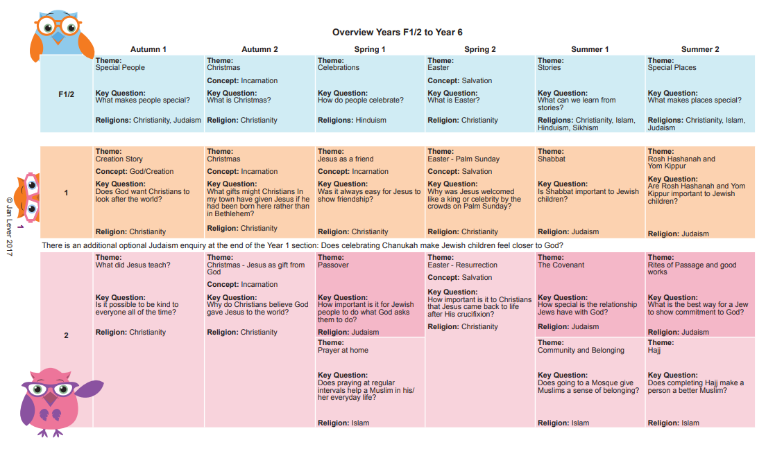
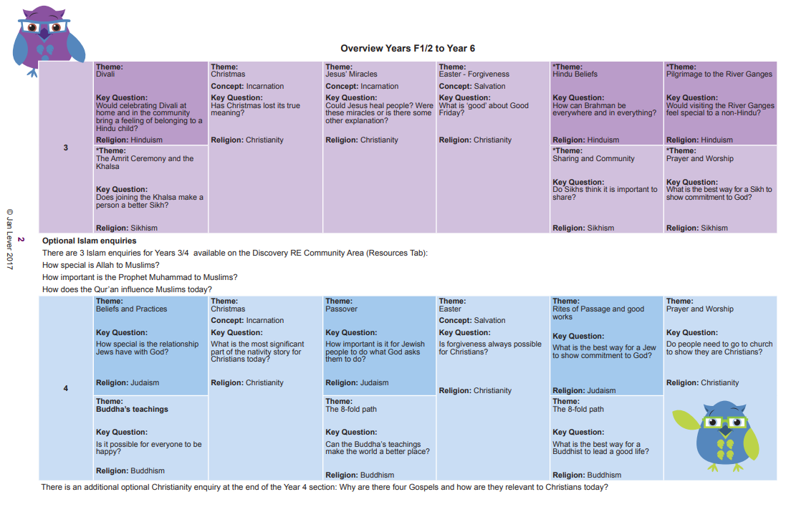
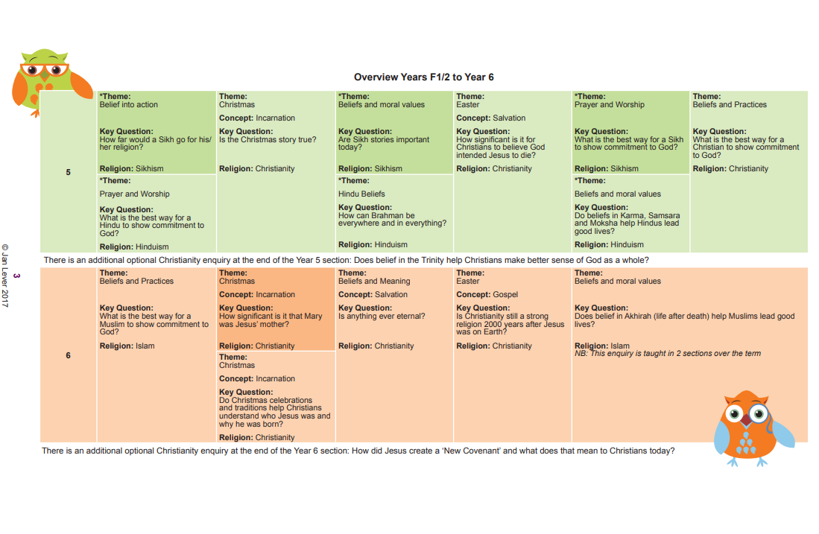
Nursery | Reception
Communication and Language (Listening, Attention and Understanding/Speaking)  - Enjoy listening to longer stories and can remember much of what happens.  - Uses a wider range of vocabulary  - Understanding ‘Why’ questions  - Sing a large repertoire of songs  - Know many rhymes, be able to talk about familiar books, and being able to tell a long story.  - Be able to express a point of view and to debate when they disagree with adult or a friend, using words as well as actions.  Personal, Social and Emotional (Self-Regulation/Managing Self/Building Relationships)  - Develop their sense of responsibility and membership of a community  - Play with one or more other children, extending and elaborating play ideas.  - Talk about their feelings using words like ‘happy’ ‘sad’ ‘angry’ or ‘worried’.  - Begin to understand how others might be feeling.  Understand the World  - Talk about what they see, using a wide vocabulary  - Begin to make sense of their own life-story and family’s history  - Continue to develop positive attitudes about the differences between people.  - Know that there are different countries in the world and talk about the differences they have experienced or seen in photo’s. | Communication and Language (Listening, Attention and Understanding/Speaking)  - Understand how to listen carefully and why listening is important.  - Learn new vocabulary  - Ask questions to find out more and to check they understand what has been said to them.  - Articulate their ideas and thoughts in well-formed sentences.  - Describe events in some detail.  - Use talk to help work out problems and organise thinking and activities, and to explain how things work and why they might happen.  - Engage in story times.  - Listen to and talk about stories to build familiarity and understanding.  - Retell the story, once they have developed a deep familiarity with the text; some as exact repetition and some in their own words  - Listen to and talk about selected non-fiction to develop a deep familiarity with new knowledge and vocabulary.  Personal, Social and Emotional (Self-Regulation/Managing Self/Building Relationships)  - See themselves as a valuable individual.  - Build constructive and respectful relationships.  - Express their feelings and consider the feelings of others.  - Think about the perspectives of others.  Understand the World  - Talk about members of their immediate family and community.  - Name and describe people who are familiar to them.  - Comment on images of familiar situations in the past.  - Compare and contrast characters from stories, including figures from the past.  - Understand that some places are special to members of their community.  - Recognise that people have different beliefs and celebrate special times in different ways.  - Recognise some similarities and differences between life in this country and life in other countries.  - Understand the effect of changing seasons on the natural world around them.
Year 1 | Year 2
- I can say how it felt to make something. I can remember the Christian Creation story and talk about it.  - I can express an opinion about the Christian belief about creation.  - I can talk about a gift that is special to me  - I can remember some of the Christmas story. I can suggest a gift I would give to Jesus.  - I can talk about my friends and why I like them.  - I can remember a story about Jesus showing friendship and talk about it. I can say how Jesus tried to be a good friend.  - I can talk about a person I admire. I can recall parts of the Easter story. I can recognise some symbols in the story.  - I can start to show understanding that Jesus is special to Christians and say why.  - I can tell you which is my favourite day of the week and talk about food I would like to share in a special meal.  - I can use the right names for things that are special to Jewish people during Shabbat and explain why.  - I can start to make a connection between being Jewish and decisions about behaviour.  - I can say how it feels to say sorry and what I have said sorry for. I can tell you something that either Rosh Hashanah or Yom Kippur is about.  - I can choose a picture and give my thinking on why this might be important to Jewsih children at Rosh Hashanah or Yom Kippur. | - I can tell you when I have been kind to others even when it was difficult.  - I can re-tell a story Jesus told about being kind or give an example of when Jesus showed kindness.  - I can say if I think Christians should be kind and give a reason.  - I can say how I could help solve a problem by showing love.  - I can remember the Christmas story and start to explain that Christians believe Jesus was a gift from God.  - I can tell you why Christians think God gave Jesus to the world  - I can talk about why I do as some people ask but not others.  - I can talk about the Seder meal, or another Jewish practice, with some detail and some of the correct vocabulary, and start to explain why they choose to do this.  - I can suggest what I think are the most and least important things Jews do that God asks them to do and add at least one reason  - I can explain how it felt to have to stop doing something to reach the target we had set.  - I can use the right words to describe how Muslims pray and begin to explain why they do this.  - I can start to think through how praying 5 times a day might help in some ways more than others.  - I can say what I believe happens to you when you die and tell you how I remember people close to me.  - I can recall what Christians believe happened on Easter Sunday.  - I can start to suggest a different explanation as to what happened to Jesus after the empty tomb and offer my opinion  - I can explain why agreements are important and why they should be kept.  - I can tell a story about Abraham or Moses and say why one of these men is important to Jews today.  - I can start to explain the significance of one thing Jews do and say how it shows their special relationship with God.  - I can explain why I could do certain things at certain ages.  - I can tell you what I am most committed to in my life.  - I can talk about one of the ways Jews show commitment to God.  - I can talk about a way that Jews show commitment to God and say why this might be important.
Year 3 | Year 4
- I can tell you three important actions I could take to support a group I belong to.  - I can discuss my understanding of my group’s symbol.  - I can describe some of the ways Hindus celebrate Divali and start to explain how I think Hindu children might feel at Divali.  - I can start to say why Divali might bring a sense of belonging to Hindus.  - I can explain what Christmas means to me and talk about whether this involves giving and receiving gifts.  - I can start to explain the Christian belief that Jesus was God in human form and why God gave him to the world.  - I can start to tell you what Christmas means to Christians and what it means to me.  - I can talk about some of the things in the world that people think of as miracles and begin to tell you about a miracle I would like to see happen today.  - I can explain one Christian viewpoint about one of Jesus’ healing miracles.  - I can start to say whether I believe Jesus actually healed people or not.  - I can suggest how a person may rescue/help others who are in difficult situations.  - I can start to tell you why Christians believe Jesus’ death is important.  - I can start to reflect on whether I agree with Christian beliefs about Jesus’ death.  - I can explain some of the different roles I play whilst still being me.  - I can describe what a Hindu might believe about one of the Hindu gods and start to understand that Brahman is in everything.  - I can recognise what I think about some Hindu beliefs about Brahman and gods, showing respect to Hindus  - I can start to evaluate the ways I show more or less commitment and can talk about when showing commitment may be difficult for me.  - I can describe some of the ways Sikhs show commitment to God, using correct language and vocabulary.  - I can start to evaluate which ways may show more or less commitment to God for Sikhs.I can explain why water is important.  - I can describe a Hindu ritual that happens at/in the River Ganges and explain why this is important and significant to the Hindus taking part in it.  - I can empathise with the special feelings a Hindu might experience when taking part in a ritual at the River Ganges. | - I can give examples of agreements and contracts and explain how I would feel if one was broken.  - I can tell you an affirmation/promise I would like to make. I can start to explain what makes Jewish people believe they have a special relationship with God.  - I can tell you some of the ways Jewish people express their special relationship with God and start to understand how that might feel.  - I can start to show an understanding of why people think it is difficult to be happy all the time. I can tell you some of the things Siddhattha did to try to be happy and explain why I think they didn’t work for him.  - I can begin to show an understanding of what being happy means to Buddhists.  - I can design a symbolic object to show the significance of Christmas or the Christmas holiday to me.  - I can describe one thing a Christian might learn about Jesus from a Christmas symbol.  - I can ask questions about what Christmas means to Christians and compare this with what it means to me.  - I can discuss why I would choose to follow an instruction not to eat certain foods, who I would listen to and why.  - I can describe some of the things Jews do to show respect to God. I can start to identify how it would feel to keep Kashrut.  - I can talk about what sort of help I might need to show forgiveness.  - I can describe what a Christian might learn about forgiveness from a Biblical text.  - I can show an understanding of how Christians believe God can help them show forgiveness.  - I can explain why I think some things need to wait until you are a certain age.  - I can give you examples of things I am committed to and explain which ones are more or less important to me.  - I can describe some of the ways that Jews choose to show commitment to God and am starting to understand that they do this in different ways.  - I can express an opinion on which ways I think might be the best ways for Jews to show their commitment to God and start to give reasons.  - I can explain some of the feelings my special place gives me and suggest why that is.  - I can describe some of the ways Christians use churches to worship/celebrate Holy Communion or participate in baptism.  - I can start to understand the impact a Christian’s special place has on him/her.  - I can say something I have learnt from Jesus’ actions that I would like to consider in my own life.  - I can describe an event that occurs in more than one Gospel and say what a Christian might learn from it.  - I can say whether or not I think it is important to have stories repeated in several Gospels, and why this might be relevant to Christians.
Year 5 | Year 6
- I can identify the different levels of commitment I show to different things and explain these priorities.  - I can make links between how Sikhs practise their religion and the beliefs that underpin this. I can respectfully ask questions about some of the ways Sikhs choose to behave and the levels of commitment they show.  - I can start to explain how ‘true’ could mean different things to different people, and how stories can be ‘true’ in different ways.  - I can start to explain the Christian belief that Jesus was the Incarnation of God. I can start to express an opinion on whether the Christmas story is true and what this might mean to Christians.  - I can explain how some stories can teach people about what is important and how to behave.  - I can recognise that stories can be an important way of expressing belief and meaning and can explain the relevance of a Sikh story.  - I can explain how some stories can teach Sikhs about what is important in life and relate this to non-Sikhs.  - I can give an example of someone with a strong sense of purpose for their life and give my opinions on this.  - I can start to explain whether God intended Jesus to be crucified or whether Jesus’ crucifixion was the consequence of events during Holy Week.  - I can start to express my opinion about Jesus’ crucifixion being his destiny/purpose.  - I can show an understanding of why people show commitment in different ways.  - I can describe how different practices enable Sikhs to show their commitment to God and understand that some of these will be more significant to some Sikhs than others.  - I can start to express what I think about the best way a Sikh could show commitment to God.  - I can show an understanding of why people show commitment in different ways.  - I can describe how different practices enable Christians to show their commitment to God and understand that some of these will be more significant to some Christians than others.  - I can explain why I think some ways of showing commitment to God would be better than others for Christians.  - I can explain how other people may have different aspects to their nature.  - I can make links between the consubstantial nature of God in 3 persons and the attributes that these persons share.  - I can reflect on the Christian belief in The Trinity and some of the sources of this belief and express thoughts on this. | - I can show an understanding of why people show commitment in different ways.  - I can describe how different practices enable Muslims to show their commitment to God and understand that some of these will be more significant to some Muslims than others.  - I can think of some ways of showing commitment to God that would be better than others for Muslims.  - I can explain the qualities needed in different people because of the important jobs they are chosen to do.  - I can make links between the Virgin Birth and Christian beliefs about Jesus (Incarnation).  - I can start to consider my own response to the Christian belief in the Virgin birth, showing respect to Christian views.  - I can express the feelings I have when I think about situations or things I would like to last forever.  - I can make links between different Christian beliefs and their views on whether anything is ever eternal.  - I can reflect on my own beliefs about whether anything is eternal I can explain how the influence people have had on me has affected what I see as important.  - I can explain how one of the reasons people use to suggest that Christianity is a strong religion today can be counteracted.  - I can give my opinion as to whether Christianity is a strong religion now and say why I think this.  - I can give examples of times my choices have been influenced and may have changed when I considered the consequences that might follow.  - I can explain how believing in Akhirah influences Muslims to do their best to lead good lives.  - I can recognise what motivates or influences me to lead a good life and compare it with what motivates and influences Muslims.  - I can give examples of times when I misinterpreted something. I can explain two different Muslim interpretations of Jihad.  - I can recognise what motivates me or influences me to lead a good life and compare it with what motivates and influences Muslims  - I can explain how I may or may not want somebody to commit to do something for me in return for my commitment.  - I can make links between the Bible texts I have chosen and the New Covenant.  - I can reflect on the Christian belief in the New Covenant and whether it is relevant to Christians today

Computing Whole School Overview
 | Autumn 1 | Autumn 2 | Spring 1 | Spring 2 | Summer 1 | Summer 2
Nursery | What is technology? |  | How do these work? |  | I can use apps!
Reception | Technology All Around Us | Let’s Paint | Let’s Write | All About Instructions | Programming with Bee Bots | Digital Literacy
Year 1 | Just Paint and write-All About Me-Part 1 | Collect Photographs and Paint Pictures Part 2 | Gathering Data and Creating Charts | Simple Algorithms and Programs Part 1 | Create Simple Programs Part 1 | Digital Literacy
Year 2 | Ways to present information | Art of animation | Collect photographs and paint pictures (Y1 objectives) | Collecting, organising and presenting data | Create simple programs (Y1 objectives) | Digital Literacy
Year 3 | Ways to present (Y2 objective) | Art of Animation (Y2 objective) | Create a Topic Based ebook (Y2 objective) | Creating a Branching Database and Interrogating Databases | Write a Program-Block Based Sequences-Part 1 | Digital Literacy
Year 4 | Storytelling and Presenting Information (Y3 objective) | QR Codes (Y3 objective) | Creating an Interrogating Simple Databases | Write a Program Part 1 Block Based Sequences | Write a Program Part 2 Drawing Shapes | Digital Literacy
Year 5 | Multi-Media Fact File (Y4 objective) | Creating and Using Spreadhseets to solve problems | What is Computer Technology? (Y4 objective) | Scratch (Y4 objective) | Scratch (Y4 objective) | Digital Literacy
Year 6 | Computers for Communication and Collaboration.(Y5objective) | Analyse and Interpret Dara Using Spreadsheets | What is Computer Technology?  (Y4 objective) | Scratch(Y4 objective) | Scratch (Y4 objective) | Digital Literacy

Nursery | Reception
Year 1 | Year 2
- I can select a photograph and write a sentence about it using JIT5 Write.  - I can take photographs and use them in J2e  - I can use photographs that my teacher has shared with me  - I can edit photographs using camera App in J2e and save them in My Files  - I can upload photographs taken in the J2e App to My Files  - I can add my Write file and Paint Files to a JIT5 Mix  - I can upload photos from the camera roll on an iPad to J2e  - I understand the importance of sequence when giving instructions  - I can use logical thinking to predict the outcome of an algorithm and a route-based program for a screen turtle  - I can create a simple route-based program for a screen turtle  - I can debug my simple route-based program for a screen turtle  - I know that there is more than one way to solve a problem, but some are more efficient than others  - I can use logical thinking to evaluate my algorithm and route-based program to improve the outcome  - I can create a tally chart  - I can analyse data from a tally chart  - I can add data to a pictogram using data from a tally chart  - I can analyse data from a pictogram  - I can add data to a bar chart using data from a pictogram  - I understand about the x and y axis and how this relates to my data  - I can analyse data from a simple bar chart  - I can create paint file in JIT  - I can use the Paint Tools to change colours and texture and fill I can save my work as a JIT file  - I can save my work as an Image (JPEG)  - I can save my drawing as a Stamp  - I can add text to a Write file I can edit my text  - I can add text to a speech bubble stamp  - I can save a JIT file, open it, change my work and resave it.  - I can explain what an algorithm is  - I can give instructions to complete a task  - I can debug an algorithm I can explain what a program is  - I can predict the outcome of a route-based program to control BeeBot  - I can write my own route-based program to control BeeBot  - I can debug my own route-based program to control BeeBot | - I can create questions with appropriate multiple-choice answers  - I can interpret data from a chart I can design a data collection sheet  - I can use a branching database to sort and organise data  - I can give a sequence of commands to complete a specific task  - I can follow a sequence of commands to complete a specific task  - I can predict the movement of the sprite to create a routebased program before I test it out  - I can debug my route-based program during running the program to correct any mistakes From given route-based programs  - I can predict the final outcome before running the program  - I can use given code as a scaffold to modify and make my own  - I can evaluate my algorithms to make judgements on its effectiveness before I create a route-based program to complete a given task  - I can use logical thinking to reverse a route-based program  - I can add an image from a shared image bank and add text to the image.  - I can create an eBook with at least 5 pages.  - I can add an image from a shared image bank and add text to the image.  - I can add a complex page with 2 images and 2 text boxes.  - I can retrieve my work from My Files in J2e, edit it and save it again  - I can create a food chain image with pictures and arrows in JIT Paint, I can save this and add it into my topic book.  - I can know that a paint file can be saved as an image  - I can name and save my work as a JiT Paint file, an image and a stamp.  - I can create several paintings and save them as pictures to use later.  - I can use the textures and colour wheel to add extra detail to my pictures I can make use of the ‘onion skin’ effect to add movement to my JiT animation.  - I know the difference between the duplicate + frame and + add frame when using JiT animate.  - I can add background images and stamps to my presentation.  - I can create a JiT Paint file and add text to it.  - I know that a frame is an individual picture and when frames are shown in a sequence create an illusion of movement to make an animation.  - I can access an image saved in My Files  - I can add a picture to a Write file and add text to it  - I can edit my text in different ways  - I can create several paintings and save them as pictures to use later.  - can retrieve my work from My Files in J2e, edit it and save it again  - I can make a simple animation of a plant growing
Year 3 | Year 4
- I know what a QR code is  - I can recognise a QR code  - I know that a QR code stores data that is machine readable that directs a user to the information  - I know how to create a QR code online  - I can scan a QR code and access the information that it links to  - I can search for appropriate images using Google  - I can save an image from Google I can upload an image to J2e  - I can add text boxes, shapes and images to a J2e5 file  - I can use layers in J2e5 I can record sound in J2e5  - I can rename a sound file in J2e5  - I can create a QR code that links to my sound recording in J2e  - I can add a QR code to my J2e5 file and print it  - I can put instructions into a sequence  - I know what an algorithm is I can predict the code from a partner’s piece of work  - I can use the command tools in Visual to create a simple program  - I can add an input to my code e.g. when a key is pressed  - I can change the sprite in Visual I can add a background sprite  - I can use the pen tool to draw letters in visual  - I can debug code to fix errors  - I know how to write an algorithm in a sentence e.g. steps to draw a shape I know this sequence can be changed into coding blocks  - I can put coding blocks into the correct order to draw a shape on the screen  - I can use the pen tools to change the colour of my shape on screen I can use column labels appropriately in a spreadsheet  - I can use a loop by using a ‘repeat‘ command  - I can add a nested loop to my code  I can explain why I have used a nested loop  - I can present and explain what I have learnt in a presentation/document  - I can create a branching database  - I can use a branching database to classify data  - I can use a simple database to search and sort information  - I understand what field and record mean in a database  - I can enter data into a class database  - I can recognise different types of data  - I can explain the difference between discrete and continuous data  - I can create charts to interpret data  - I can find errors in a database  - I understand that there is a difference between a computer and paper-based database | - I understand what an input is  - I can move a sprite up, down, left and right using different inputs such as keyboard and mouse  - I can change the look of a sprite, through code, to switch between costumes  - I understand how and when to use the wait command in coding  - I understand the need for a continuous loop in programming  - I understand that selection in programming uses if then statements  - I can compare block-based code to an algorithm and identify where changes need to be made in the code to match the algorithm  - I can explain the difference between hardware and software  - I can explain the difference between an input and an output device  - I can name the internal parts of a computer that make it work  - I know that data stored in the computer’s memory are called BITS  - I know that a BIT can either be 1 or 0  - I know how the RAM helps the CPU to carry out tasks  - I know that 8 bits is known as a 1 byte I know that letters, numbers and symbols are stored as bytes in the computer’s memory  - I can explain what a pixel is I understand that how images are stored in the computer’s memory is different to how the computer’s memory stores data on letters, numbers and symbols  - I understand binary data and can re-create a binary image following bit data  - I know the difference between analogue and digital methods for storing, searching and sorting data.  - I am able to identify different data types and explain when they might be used  - I will be able to create appropriate questions to gather useful data that is fit for purpose  - I understand the relationship between a record and a database  - I understand a simple database structure.  - I can add data to a class database, under the correct fields, using the correct data types  - I can sort and search through information to answer specific questions  - I can change the background  - I can upload a sprite from the sprite library  - I can change costumes of my sprites  - I can add the music extension block to a scratch file  - I can duplicate and edit sprites using the drawing tools in scratch  - I can create a sequence – a set of programming blocks to play a tune I can create a controlled count loop ‘repetition’ – a sequence of instructions that is repeated a certain number  - I can add a forever loop to my code  - I can save my work (either to a computer or in my scratch account  - I can create a broadcast message and use it in a block of code.
Year 5 | Year 6
- I know that the internet allows us to communicate with people all over the world through audio, text and video  - I can explain what some of the risks are when communicating online with others  - I know what email is and how to write an email  - I know what instant or direct messaging is  - I know that instant/direct messaging can be to one person or to many at the same time  - I know what a wiki is I know the difference between misinformation and disinformation  - I can suggest suitable strategies to help with spotting fake news when gathering information online  - I can work collaboratively online to create and present information  - I can use text boxes, images and hyperlinks to present information  - I can name some famous men and women that have been instrumental in the development of computers and technology  - I know what a cell reference/cell address is  - I know how to generate lists of numbers using the autofill tool  - I can create simple formulae to perform calculations in a spreadsheet  - I can make my formulae more efficient through using the inbuilt formulae functions and cell references  - I can use column labels appropriately in a spreadsheet  - I can explain how formulae work in a spreadsheet  - I can use a spreadsheet to help solve problems  - I can use the editing tools to improve the legibility of a spreadsheet table and display decimal places  - I can present and interpret information in a graph  - I can explain what an infographic is  - I can make judgements on the design of an infographic to evaluate its effectiveness  - I understand that colour can impact the design of an infographic due to meanings and associations as well as colour combinations  - I know that carefully selecting images to convey the right message is important I understand that I should abide by copyright licences if I am to use someone else’s image in my own work  - I can use charts and graphs appropriately to display data  - I have considered the overall design and limited my use of colour and images so as not to distract from the intention of the infographic  - I have used a variety of presentation skills such as layering, transparent images, coloured text, filled text boxes and background fills to design my infographic  - I have carefully chosen interesting and related facts and stats to convey the intended message for my infographic  - I can use selection if touching another sprite then…do something  - I can move a sprite with the mouse  - I can use selection – if on the edge bounce block  - I can understand the point in direction tools  - I can use nested loops to make sprites move  - I can make and use a simple variable  - I can create and use a procedure that helps run code over and over, so I don’t have to re-write it  - I can make a sprite move by using selection within a nested loop when the arrow key is pressed  - I understand the difference between the x and y axis and effectively use this knowledge to create a falling sprite. | - I can create simple formulae to perform calculations in a spreadsheet  - I can create formulae to find the min and max scores in a game  - I understand the importance of expressing formulae correctly  - I can create formulae to carry out each one of the four basic mathematical functions  - I understand which variables to change and can predict what the effect of changing the variable will be to answer ‘what if?’ questions  - I can use the editing tools to improve the legibility of a spreadsheet table and display decimal places  - I can design and create a functional spreadsheet that includes working formulae, to answer a real-life problem  - I can abstract information fit for purpose and use it in a spreadsheet to model answers to the problems  - I Can use selection if touching another sprite then…do something  - I can move a sprite with the mouse  - I can use selection – if on the edge bounce block  - I can understand the point in direction tools  - I can use nested loops to make sprites move  - I can make and use a simple variable  - I can create and use a procedure that helps run code over and over, so I don’t have to re-write it  - I can make a sprite move by using selection within a nested loop when the arrow key is pressed  - I can use the conditional If/Else block in my code  - I know that Boolean logic relies on true or false statements and can use this in my code  - I can explain what the internet is.  - I can explain what the world wide web is.  - I know that binary code is the most basic language a computer understands.  - I know that information is broken into pieces called packets and travel across networks, taking different routes in order to reach their destination quickly and efficiently.  - know what a web browser is and how it is different to a search engine  - I understand what a web crawler is and how it links to a search engine  - I understand how search engines select and rank results using page ranking processes and algorithms  - I can read the anatomy of a search result to make better choices of the reliability and validity of a web site as an accurate information source  - I know that there are two types of fake news and can explain what they are  - I know what a computer virus is and can give examples  - I know what a hacker does and can give examples of how you can become a victim  - I can identify good practice advice to follow for better computer and network security  - I know what phishing is  - I can identify the features of scam communications  - I can explain what big data means #  - I can explain what digital footprints means  - I can evaluate my own digital footprint  - I can explain why understanding terms and conditions for online platforms is important  - I can give examples of some of the rights companies have when you agree to their terms and conditions  - I can give examples of some of the rights companies have when you agree to their terms and conditions  - I can explain what an ethical hacker is and what they do  - I can explain why a hacker might want to steal data I can explain what website cookies are  - I can explain why someone would or would not want cookies enabled on their computer  - I can explain the pros and cons of accepting cookies  - I can explain multiple ways in which big data is used for good

British Sign Language
Autumn | Spring | Summer
Alphabet, Greetings and numbers 0-20 | Emotions/feelings and Family | Days of the week/Months of the year and weather/seasons and colours
- I can fingerspell my name  - I can do the BSL alphabet  - I can use basic greetings – How are you?  - I can have basic conversations  - I can use my body language to support BSL communication  - I can use my facial expressions to support BSL communication  - I can count to 20 in BSL  - I can use my sign name | - I can fingerspell my sibling’s/peers names  - I can use the BSL signs for the members of my family  - I can ask my peers - How are you? Etc…  - I can use BSL to express my feelings/emotions  - I can use my body language to support BSL communication  - I can use my facial expressions to support BSL communication  - I can use my sign name | - I can sign the days of the week  - I can use the BSL to describe the weather  - I can sign the months of the year  - I can sign the four seasons  - I can use BSL to describe colours  - I can sing the rainbow song  - I can use my body language to support BSL communication  - I can use my facial expressions to support BSL communication  - I can use my sign name

